

**Doorstep Duets**   
**Stage Manager**

Application Pack   
Application Deadline:

Tuesday 22 April @ 10am

## Stage Manager Application Pack

Thank you for your interest in the role of Stage Manager on Doorstep Duets at New Adventures.

This pack includes:

* how to apply
* information about the company
* a job description
* a person specification
* guidance for applicants

## How to apply

Before applying, please read the information and guidance notes provided in this pack carefully. We appreciate the time it takes in applying for roles and we want you to have the opportunity to tell us about yourself and explain why this position is right for you in whatever way feels most appropriate to you. All applications will be considered based on content, not on format.  

Please send one of the following, together with a CV:

* A cover letter (maximum two A4 sides – either bullet points or full sentences, whichever you feel more comfortable with)

OR

* Presentation - Keynote or PowerPoint

OR

* Short video or sound file (5 minutes max)

All applications should address the following:

* Who you are.
* What you could bring to New Adventures in this role.
* Your suitability for the position and specifically how your experience matches the role, job description and person specification.
* Provide details of two people who can comment on your work professionally including your current or previous employer. Please indicate how long and in what capacity your referees have known you. Referees will not be contacted without your permission.

[We also ask applicants to complete our equal opportunities monitoring form which can be completed here.](https://forms.office.com/pages/responsepage.aspx?id=KWOLic819ECLIP5O_rLkcNSvoL3rcDtCgqtXNdMw1sBUQUs4SlZVM1FESU5QMjZDUUUxNzhKWlFTTi4u&route=shorturl)

Completion of the form is optional and every question has a ‘prefer not to say’ option. Your answers really help us to understand how we are doing when trying to attract a broad range of candidates. The form will be kept separate from your application and will not be seen by the recruitment panel or form any part of the assessment of your application.

The deadline for applications is: **Tuesday 22 April @ 10am**.

## Submitting your application

If you are applying in writing, please submit your CV, expression of interest and equal opportunities monitoring form to Louise Miller, [louisemiller@new-adventures.net,](mailto:louisemiller@new-adventures.net) with the subject field marked ‘Stage Manager Doorstep Duets Application’.

You can upload a video or audio file along with your equal opportunities form and CV to us using the We Transfer service <https://wetransfer.com/> – when using this service please send your file to Louise Miller, [louisemiller@new-adventures.net](mailto:louisemiller@new-adventures.net), with ‘Stage Manager Doorstep Duets Application’ in the subject line.

Your equal opportunities monitoring form should be completed online. If you require any support completing the form in this way, please let us know.

All applications will be acknowledged.

#### Recruitment and Project Timeline

Application Deadline Monday 22 April @ 10am

Applicants invited to interview by 2 May 2025

Interviews wc 05 May 2025

Prep Week Monday 9 June – Friday 13 June 2025

Rehearsals Monday 16 June – Saturday 28 June 2025

Project Delivery Monday 30 June – Saturday 26 July 2025

Equipment and materials returns One day week commencing 28 July 2025

In addition, you may also be required for a post-project debrief session, date to be confirmed. Please let us know within your application if you are not available on any of the above days.

**Interview Information**

The interview will be a panel interview with a maximum 3 people that will last no longer than one hour. The names of the interview panellists, interviews questions and interview task will be shared with you in advance.

Please let us know within your application if you are not available on the date above. It is our intention that interviews will take place at our office in London, however we can also hold interviews remotely. This will be discussed further on invitation to interview.

**Commitment to Access**

We will support any access requirements you may have during the recruitment process and ensure that reasonable adjustments are in place. If you have any access requirements, or barriers to access that you would like to discuss, please do not hesitate to let us know either before applying or as part of your application.

Candidates who are shortlisted for interview will be given the opportunity to specify any access requirements so that appropriate arrangements can be made. If you require this application pack in an alternative format, please contact us.

**For Further Information**

For an open and informal and confidential chat about the role, or to ask any questions, please contact Alex Towers, Schools & Young People Producer, on 01252 597050 or alex@new-adventures.net.

## about the company

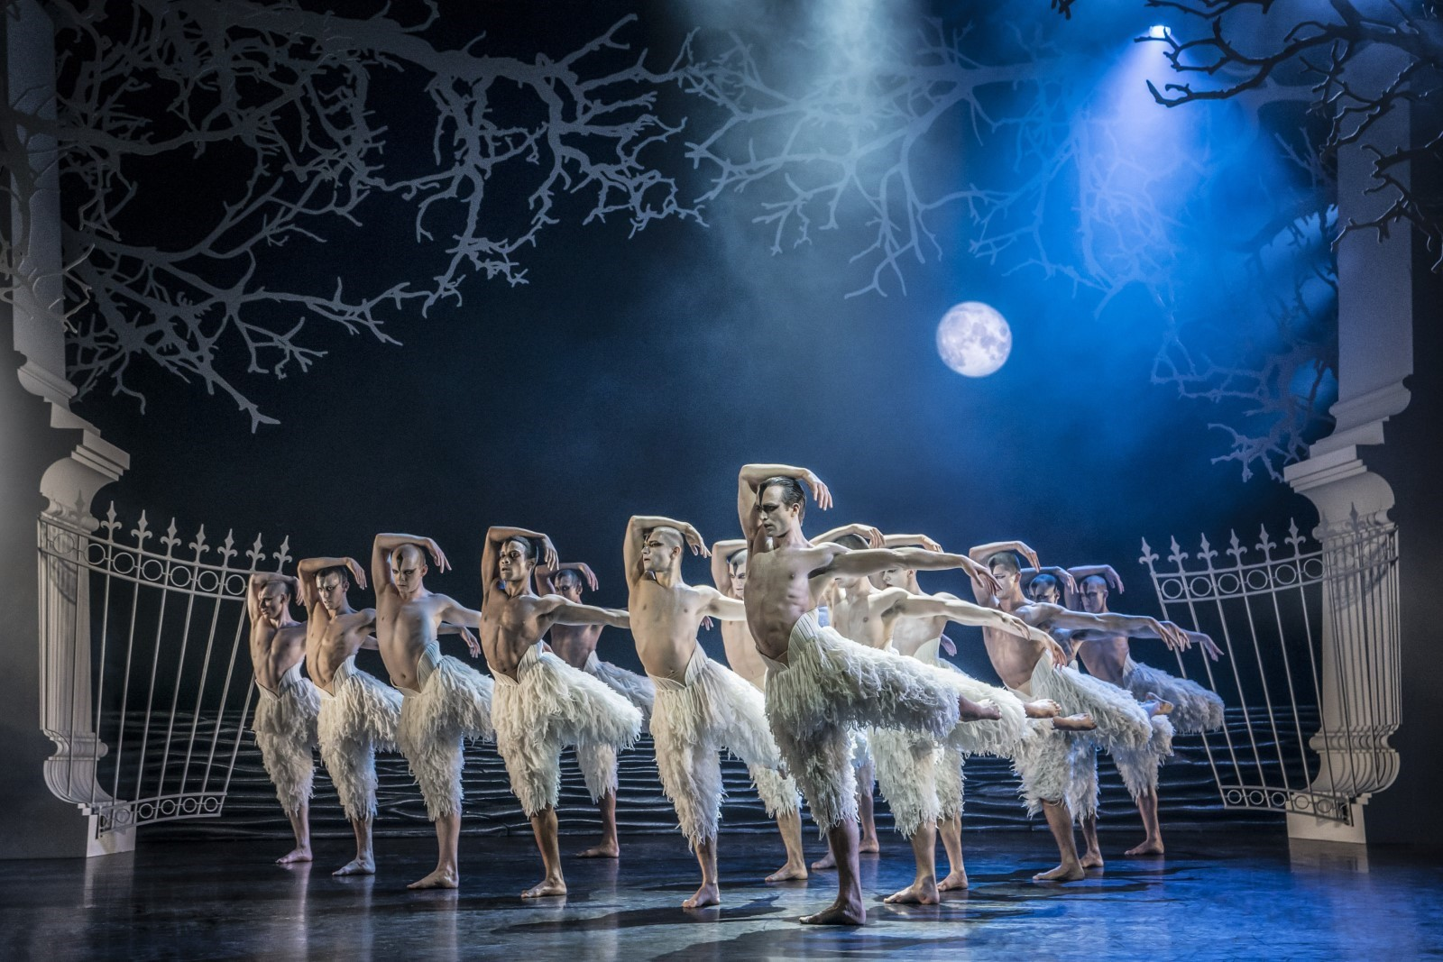**Matthew Bourne’s *Swan Lake* (Photo: Johan Persson)**

Matthew Bourne’s New Adventures is an award-winning, ground-breaking British dance-theatre company, famous for telling stories with a unique theatrical twist. Since 1987 New Adventures has changed the popularity of dance in Britain, creating works that have altered the public perception of what is possible when it comes to telling stories without words.      
    
New Adventures is a charity, and its principal funder is Arts Council England. As well as producing award-winning productions which dazzle audiences across the globe, New Adventures is committed to playing a meaningful role in diversifying the dance landscape for future generations. The company’s Take Part work reaches thousands each year through transformative workshops and masterclasses to schools and communities across Britain; the company’s many strands of talent development work nurture the best emerging talent from communities across the UK, springboarding them into our company and the wider sector.

**We work in the following key areas:**

➔  On Stage – large-scale, innovative and highly popular works that tour nationally and internationally .

➔  Talent Development – nurturing the next generation of dancers and choreographers, particularly seeking out those who have been historically excluded from pathways into the arts  .

➔  Young people and communities – participatory activity for people of all ages, including workshops, residencies and large-scale projects in partnership with other organisations

➔  REEL Adventures – ways of delivering on film, broadcast and digital platforms .

**Our core values are:**

➔  Audience – Our audiences are why we do what we do. Entertaining, engaging and inspiring audiences is our passion. We proudly tour to more venues and give more performances each year than any other dance company in the UK. We strive to be widely accessible and welcoming to both our loyal and new audiences.

➔  Adventure – Since the beginning we have been bold, maverick and adventurous. 30 years on we continue to push boundaries and defy expectations in dance, storytelling and ambition. We are committed to reaching as many people and places as possible through our productions and projects.

➔  Family – We have a shared commitment to supporting, developing and investing in all members of the New Adventures company and everyone involved with our work in whatever capacity – performers, creatives, crew, staff, practitioners, audiences, participants, trustees, students, interns, volunteers and partners. We all matter.

**Commitment to Equity, Diversity, and Inclusion**

New Adventures is committed to achieving a working environment which provides equity of opportunity and freedom from discrimination, harassment, and bullying. We believe that everyone is entitled to be treated with respect and dignity.   

One of our core company values is Family and we have a long-held and shared commitment to supporting, developing, and investing in all members of the New Adventures company and everyone involved with our work in whatever capacity - performers, creatives, crew, staff, dance artists, audiences, participants, trustees, students, and partners.   

We work together with partners e.g. [Creative Access](https://creativeaccess.org.uk/) and [Global Butterflies](https://globalbutterflies.com/), to help us achieve these aims.

We encourage applications from candidates of all backgrounds and welcome different points of view, skills, and stories.

Our freelancers, staff team and Trustees are actively engaged in equity, inclusion, and anti-racism work through programmed, facilitated learning sessions and our Equity, Diversity, Inclusion and Access (EDIA) Working Group. Anyone joining the company is expected to support and promote our Equity, Diversity, and Inclusion Policy.

## About Doorstep Duets

Doorstep Duets was originally created in 2021 by New Adventures and Farnham Maltings as a response to social isolation. It offers an opportunity for people to enjoy free, world-class performances in their local neighbourhood, on their street, in local parks and through community organisations. The aim of the project is to share joy, offer escapism, and make dance more accessible to all. In true company style, the pieces choreographed for Doorstep Duets are always lively, characterful, and full of happiness.

Doorstep Duets at Farnham Maltings 
Four dancers with arms outstretched on the grass outside a red brick building.

*High Tide* at Farnham Maltings, part of Doorstep Duets 2022 (Photo: Stephen Daly)

## Job Description: Stage Manager

### Purpose

The Stage Manager will be responsible for all technical and production elements of Doorstep Duets and will support the Doorstep Duets Project Producer, Assistant Producer, Choreographer and Resident Director in the delivery of the project. The actual technical elements of the production are minimal. The performance will be twenty minutes long and will be performed multiple times a day to different community audiences and in different external and internal spaces.

This role is key to ensuring that the project runs smoothly and efficiently. The right candidate will be proactive, excited by a diverse and varied workload, and will have excellent communication skills.

The Stage Manager will be responsible to the Doorstep Duets Project Producer.

### Key Responsibilities of the role

**Production**

* Leading on securing props, costumes, and furnishings with support from the Assistant Producer.
* Responsible for writing and circulating call times to the Doorstep Duets company as well as communicating schedule or other project updates as appropriate.
* Driving a hired car or van to transport set, props, and performers between performance venues each day in a timely and efficient manner.
* Leading on the set-up of any set and prop elements for the performances at each performance venue.
* Responsible for operating sound for each performance, which will involve queuing sound through a portable Bluetooth speaker via a company laptop.
* Responsible for the safe storage and maintenance of props, set pieces, costume and technical equipment (i.e., Bluetooth speaker) to ensure that all production elements are ready for the next performance and any replacements are sourced as quickly as possible.
* Responsible for organising or carrying out costume laundry duties approximately once a week.
* Responsible for compiling a daily show report to be circulated with the project team and New Adventures staff via email at the end of each performance day.
* To work with the Doorstep Duets Project Producer, Assistant Producer and other members of the project team as appropriate to problem solve matters arising as required throughout the project.
* To support the Doorstep Duets Project Producer with taking responsibility for the pastoral care of the Doorstep Duet’s company whilst on tour.
* To support the delivery of Access performances that are scheduled as part of the performance schedule (i.e. Audio Described or British Language Interpreted performances)
* To work with the Environmental Sustainability Manager and Doorstep Duets Project Producer to support and help realise New Adventures’ sustainability ambitions for the project.
* At the end of the project, to return the project’s equipment and materials to the New Adventures office, ensuring the show’s prompt book and project inventory is up to date.

**Financial**

* Working with the Doorstep Duets Project Producer and Finance Manager to manage petty cash expenditure or lines of the production budget as delegated.
* Working with the Doorstep Duets Project Producer and the Finance Manager to organise receipts for the tour to ensure all petty cash is reconciled in an orderly and timely manner, using the expenses platform Soldo as required.

**Data**

* To lead on capturing audience numbers (headcounts) whilst on tour and recording these in daily show reports for circulation.

**General**

* To always work in accordance with New Adventures’ Environmental Policy and Action Plan.
* To embody the New Adventures policies and any other policies or plans New    
  Adventures may introduce in the future.

**Other**

* To always act in the best interests of the New Adventures.
* To be an enthusiastic advocate of New Adventures.
* Other duties as reasonably required by the Doorstep Duets Project Producer.

### Person Specification

**Knowledge & Experience**

* Do you have experience in stage management in small-scale touring and / or community arts?

**Skills & Attributes**

* Do you have a full, clean driving licence and the ability to drive a manual car?
* Are you highly organised person with a proven ability to prioritise a wide range of tasks with effective time management to meet deadlines?
* Do you approach your work with a high level of accuracy and attention to detail?
* Do you have excellent and confident interpersonal and communication skills?
* Are you skilled in planning ahead and problem solving?
* Are you able to work with tact, diplomacy, and complete confidentiality when working with others?
* Are you flexible, approachable, and adaptable, with the ability to work well within a small team?

**Personal Attributes**

* Do you have a passion for and understanding of community arts?
* Do you have a positive, approachable, can-do attitude?
* Do you enjoy working as part of a small team?

We will be using this to shortlist applicants. There may be some questions here that you can't confidently answer ‘yes’ to – don't be put off by this. If you still feel that you could do the job well, we want to hear from you.

## Summary of Main Terms and Conditions

|  |  |
| --- | --- |
| Fee: | £650 per week  £100 additional per touring week for laundry responsibilities  £100 additional per touring week for driving responsibilities  £110 day-rate for any prep and returns days   £34 fee for a post-project debrief session  During rehearsals, subsistence and travel is provided if you live outside of London. During the tour, accommodation, per diems and travel will be provided. Any additional insurance costs will be covered by New Adventures. |
| Contract: | Freelance, Fixed term. Contract would run from 9 June for prep week finishing week of 28 July (one day to be worked this week for equipment and material returns and inventory in office). |
| Hours of work: | 10am – 6pm, Monday-Saturday |
| Location: | Rehearsals will take place at Week 1: Farnham and Surrey  Week 2: Essex (Colchester area)  Week 3: Kent (including Canterbury, Dover and Thanet)   Week 4: Surrey Libraries and one day in Suffolk |
| Line Manager: | Doorstep Duets Project Producer |
| Identity Checks: | The successful applicant will need to provide official documents to confirm that they have the right to work in the UK and undergo a check with the Disclosures and Barring Service (DBS). New Adventures will cover the cost of a DBS check if required. |
| References: | All offers of employment will be subject to the receipt of satisfactory references. |

|  |  |
| --- | --- |
| Company  Benefits: | Employee Assistance Programme via Health Assured |

## Equal Opportunities

New Adventures strives to be an Equal Opportunities Employer and to ensure that no person is unfairly discriminated against in its recruitment and selection policies and procedures. New Adventures welcomes applications from all sectors of the community, regardless of age, disability, gender identity or gender expression, race, ethnicity, religion or belief, sex, sexual orientation, or any other identity characteristic and makes appointments based solely on ability to fulfil the duties of the post. We actively welcome applications from individuals with backgrounds currently underrepresented in the arts.

Your application and any associated personal information will be stored and processed in accordance with our [Privacy Policy](https://new-adventures.net/legal/cookies). We will keep your equal opportunities form for a period of 6 months, after which point the data will be anonymised and aggregated for monitoring purposes. If you are employed by us, the information you supply will be kept securely and will form part of your employment record. All information will be treated in confidence and will not be seen by staff directly involved in the appointment and used only to provide information for monitoring and evaluation purposes.