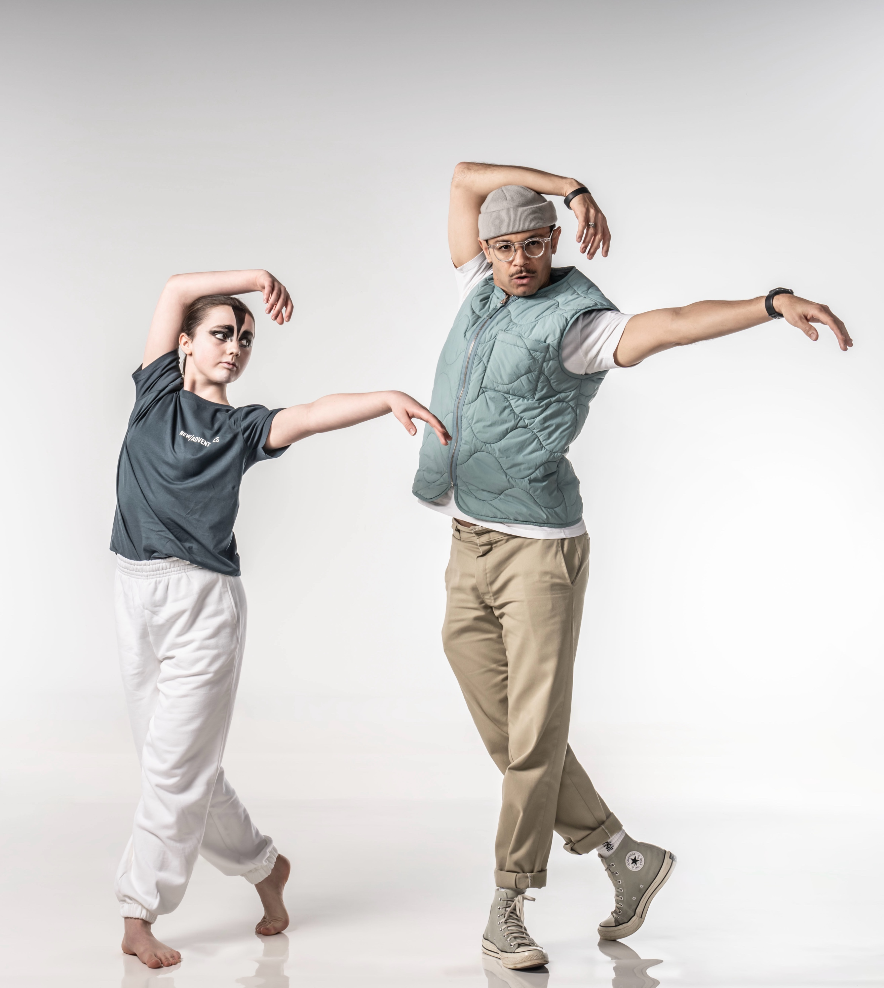

# 

# REGIONAL DANCE AMBASSADOR

**JOB PACK**

## REGIONAL DANCE AMBASSADOR job PACK

Thank you for your interest in the role of **Regional Dance Ambassador** for **New Adventures’ Swan Lake Take Flight** project in partnership with (Venue).

**About New Adventures** 

New Adventures is an iconic and ground-breaking dance-theatre company. Since 1987, it has been known for creating works that have altered the public perception of what is possible when it comes to telling stories without words. The company is led by celebrated choreographer and director, Sir Matthew Bourne. New Adventures has become the most successful and busiest dance company in the UK and is a major exporter of British dance across the world.

**Swan Lake Take Flight** 

In 2024-25 New Adventures is touring its pioneering production of Matthew Bourne’s Swan Lake. To coincide with this 30th anniversary UK tour, we have an ambition to reach over 2,500 young people in local communities through Swan Lake Take Flight. The project will be delivered in partnership with 6 Placemaking venues, as we seek to support relationships between venues and local community groups and bring new audiences into theatres across the country. The activities that make up this project are inspired by Swan Lake and will engage young people in dance, focussing on how connecting, creating, and moving together can improve wellbeing.

**Regional Dance Ambassador** 

The Regional Dance Ambassador will:

* Attend 3-day intensive training with New Adventures.
* Lead up to 10 movement workshops locally with up to 25 participants per workshop across a 4-5 week period.
* Support the running of Take Flight days with New Adventures Dance Artists.
* Watch Swan Lake at their local venue with participants from Take Flight days.
* Take part in the evaluation over the course of the whole project.

The regional dance ambassador will receive training from New Adventures to deliver this work. The aim is to create a bespoke legacy with the dance ambassador and the venue to continue leading and promoting dance in the local area.

**Key working relationships** 

Kerry Biggin - Take Part Creative Director

Leah Fox – Swan Lake Take Flight Producer

New Adventures Dance Artists

(Venue contact)

**Person Specification**

**Knowledge and experience**

* Do you have experience working with young people in your local region?
* Do you have experience of teaching dance?
* Do you have a passion and commitment to develop dance in your local region?

**Skills and Attributes**

* Do you have an interest in developing your movement practice?
* Do you believe in the power of promoting wellbeing through the arts?
* Do you have an interest in storytelling through movement and New Adventures work?
* Do you have a passion for inspiring young people?

**Summary of Freelance Contract**

**Fee:**

* £33 per online briefing/mentoring or evaluation session.
* £139 per training day and community workshop delivery.
* £196 per Take Flight Day support.
* Travel and accommodation to London will be covered.

**Hours and Location of Work:**

* 3 training days in London.
* 10 Community Workshops up to an hour long, delivered in local region.
* 2 Full day Take Flight days delivered at local venue.
* 8 online briefing/mentoring and evaluation sessions of an hour.

(draft venue schedule dates)

**How to apply** 

Please send **one** of the following to (email/link), together with a CV and [completed equal opportunities form](https://forms.office.com/Pages/ResponsePage.aspx?id=KWOLic819ECLIP5O_rLkcNSvoL3rcDtCgqtXNdMw1sBURVE1NTlFQ1RBNlVUMDZDVUU4OUlWUkUyVy4u):

* A cover letter (maximum two A4 sides – either bullet points or full sentences, whichever you feel more comfortable with) **OR**
* Presentation - Keynote or PowerPoint **OR**
* Short video or sound file (5 minutes max)

All applications should address the following:

* Who you are
* What you could bring to (Theatre) and New Adventures in this role
* Your suitability to be a Regional Dance Ambassador in (city) and specifically how your experience is aligned with this role.
* Provide details of two referees who can comment on your work professionally including your current or previous employer.

**The deadline for your application is:** (date)

If your application is successful, there will be an interview and observation of practice.

**Commitment to Access:**   
We will support any access requirements you may have during the recruitment and delivery process and ensure that reasonable adjustments are in place. Please do not hesitate to let us know either before applying or as part of your application.

**For Further Information**

For an open and informal and confidential chat about the role, or to ask any questions, please contact Leah on 07821 110170or [leah@new-adventures.net](mailto:leah@new-adventures.net)

