

DOORSTEP DUETS
STAGE MANAGER

Application Pack
Application Deadline: Tuesday 26th May @ 10am

Stage Manager Application Pack
Thank you for your interest in the role of Stage Manager on Doorstep Duets at New Adventures.
This pack includes:
- how to apply
- information about the company
- a job description
- a person specification
- guidance for applicants

How to apply
Before applying, please read the information and guidance notes provided in this pack carefully. We appreciate the time it takes in applying for roles and we want you to have the opportunity to tell us about yourself and explain why this position is right for you in whatever way feels most appropriate to you. All applications will be considered based on content, not on format.
Please send one of the following, together with a CV:
- A cover letter (maximum two A4 sides – either bullet points or full sentences, whichever you feel more comfortable with)
OR
- Presentation - Keynote or PowerPoint
OR
- Short video or sound file (5 minutes max)

All applications should address the following:
- Who you are.
- What you could bring to New Adventures in this role.
- Your suitability for the position and specifically how your experience matches the role, job description and person specification.
Provide details of two people who can comment on your work professionally including your current or previous employer. Please indicate how long and in what capacity your referees have known you. Referees will not be contacted without your permission.
We also ask applicants to complete our equal opportunities monitoring form which can be completed here.
Completion of the form is optional, and every question has a ‘prefer not to say’ option. Your answers really help us to understand how we are doing when trying to attract a broad range of candidates. The form will be kept separate from your application and will not be seen by the recruitment panel or form any part of the assessment of your application.
The deadline for applications is: 26th May 2026 @ 10am.

Submitting your application
If you are applying in writing, please submit your CV, expression of interest and equal opportunities monitoring form to recruitment@new-adventures.net, with the subject field marked ‘Stage Manager Doorstep Duets Application’.
Please ensure your full name is included in the file name of any files you send to us.
You can upload a video or audio file along with your equal opportunities form and CV to us using the We Transfer service https://wetransfer.com/ – when using this service please send your file to, recruitment@new-adventures.net, with ‘Stage Manager Doorstep Duets Application’ in the subject line.
Your equal opportunities monitoring form should be completed online. If you require any support completing the form in this way, please let us know.
All applications will be acknowledged.

Recruitment and Project Timeline
Application Deadline Tuesday 26th May @ 10am
Applicants invited to interview by Friday 29th May
Interviews Week Commencing 1 June 2026
Prep Week Monday 22 June – Friday 26 June 2026
Rehearsals Monday 29 June – Saturday 11 July 2026
Project Delivery Monday 13 July – Saturday 8 August 2026
Equipment and materials return 1 x day - week commencing 10 August 2026
In addition, you may also be required for a post-project debrief session, date to be confirmed. Please let us know within your application if you are not available on any of the above days.

Interview Information

The interview will be a panel interview with a maximum three people that will last no longer than one hour. The names of the interview panellists, interviews questions and interview task if applicable will be shared with you in advance.
Please let us know within your application if you are not available on the date above. It is our intention that interviews will take place at our office in London, however we can also hold interviews remotely. This will be discussed further on invitation to interview.

Commitment to Access
We will support any access requirements you may have during the recruitment process and ensure that reasonable adjustments are in place. If you have any access requirements, or barriers to access that you would like to discuss, please do not hesitate to let us know either before applying or as part of your application.
Candidates who are shortlisted for interview will be given the opportunity to specify any access requirements so that appropriate arrangements can be made. If you require this application pack in an alternative format, please contact us.

For Further Information

For an informal chat about the role, or to ask any questions, please contact Zeynep Gunaydin, Take Part Producer- Communities, on 01252 597050 or zeynep@new-adventures.net.

about the company
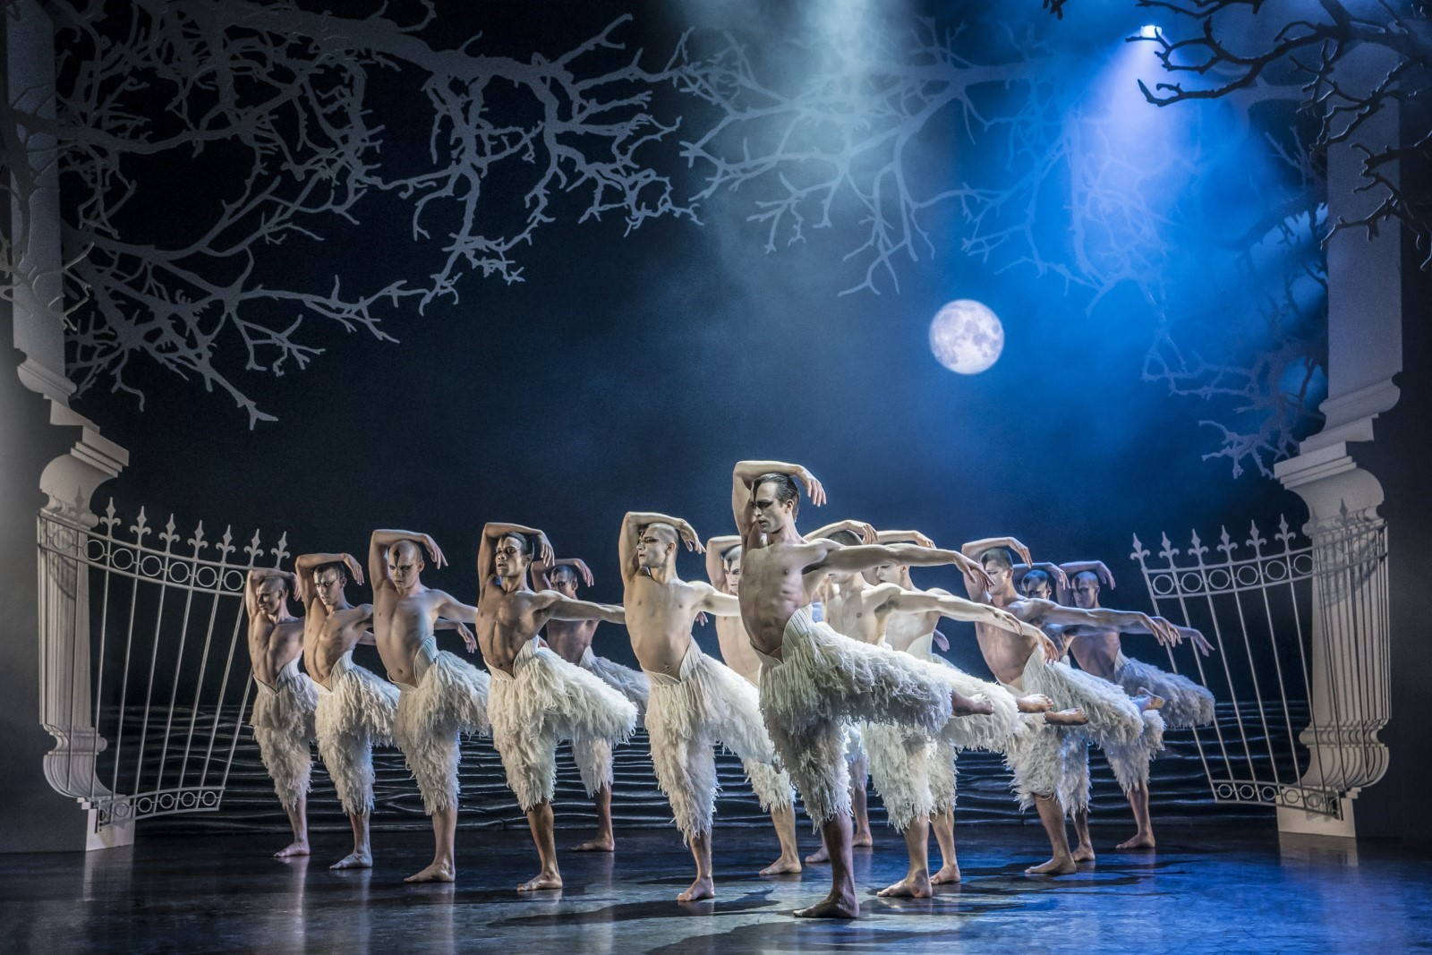Matthew Bourne’s Swan Lake (Photo: Johan Persson)
Matthew Bourne’s New Adventures is an award-winning, ground-breaking British dance-theatre company, famous for telling stories with a unique theatrical twist. Since 1987 New Adventures has changed the popularity of dance in Britain, creating works that have altered the public perception of what is possible when it comes to telling stories without words.
New Adventures is a charity, and its principal funder is Arts Council England. As well as producing award-winning productions which dazzle audiences across the globe, New Adventures is committed to playing a meaningful role in diversifying the dance landscape for future generations. The company’s Take Part work reaches thousands each year through transformative workshops and masterclasses to schools and communities across Britain; the company’s many strands of talent development work nurture the best emerging talent from communities across the UK, springboarding them into our company and the wider sector.
We work in the following key areas:
➔ On Stage – large-scale, innovative and highly popular works that tour nationally and internationally .
➔ Talent Development – nurturing the next generation of dancers and choreographers, particularly seeking out those who have been historically excluded from pathways into the arts .
➔ Young people and communities – participatory activity for people of all ages, including workshops, residencies and large-scale projects in partnership with other organisations
➔ REEL Adventures – ways of delivering on film, broadcast and digital platforms .

Our core values are:

➔ Audience – Our audiences are why we do what we do. Entertaining, engaging and inspiring audiences is our passion. We proudly tour to more venues and give more performances each year than any other dance company in the UK. We strive to be widely accessible and welcoming to both our loyal and new audiences.
➔ Adventure – Since the beginning we have been bold, maverick and adventurous. 30 years on we continue to push boundaries and defy expectations in dance, storytelling and ambition. We are committed to reaching as many people and places as possible through our productions and projects.
➔ Family – We have a shared commitment to supporting, developing and investing in all members of the New Adventures company and everyone involved with our work in whatever capacity – performers, creatives, crew, staff, practitioners, audiences, participants, trustees, students, interns, volunteers and partners. We all matter.

Commitment to Equity, Diversity, Inclusion and Access

New Adventures is committed to achieving a working environment which provides equity of opportunity and freedom from discrimination, harassment, and bullying. We believe that everyone is entitled to be treated with respect and dignity.
One of our core company values is Family and we have a long-held and shared commitment to supporting, developing, and investing in all members of the New Adventures company and everyone involved with our work in whatever capacity - performers, creatives, crew, staff, dance artists, audiences, participants, trustees, students, and partners.
We work together with partners e.g. Access All Areas, Take The Space and Global Butterflies, to help us achieve these aims.

We encourage applications from candidates of all backgrounds and welcome different points of view, skills, and stories.

Our freelancers, staff team and Trustees are actively engaged in equity, inclusion, and anti-racism work through programmed, facilitated learning sessions and our Equity, Diversity, Inclusion and Access (EDIA) Working Group. Anyone joining the company is expected to support and promote our Equity, Diversity, and Inclusion Policy.



About Doorstep Duets
Doorstep Duets was originally created in 2021 by New Adventures and Farnham Maltings as a response to social isolation. It offers an opportunity for people to enjoy free, world-class performances in their local neighbourhood, on their street, in local parks and through community organisations like care homes, hospices and community hubs/ food banks. The aim of the project is to share joy, offer escapism, and make dance more accessible to all. In true company style, the pieces choreographed for Doorstep Duets are always lively, characterful, and full of happiness.

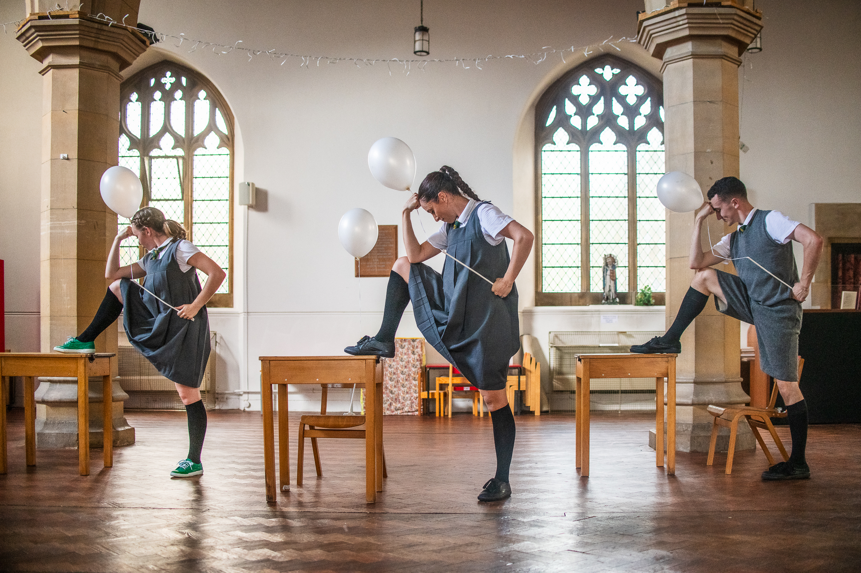
My Feet Don’t Quite Touch the Floor at Farnham Maltings, part of Doorstep Duets 202(Photo: Stephen Daly)

Job Description: Stage Manager

Purpose
The Stage Manager will be responsible for all technical and production elements of Doorstep Duets and will support the Take Part Producer- Communities, Assistant Producer, Choreographer and Resident Director in the delivery of the project. The actual technical elements of the production are minimal. The performance will be twenty minutes long and will be performed multiple times a day to different community audiences and in different external and internal spaces. This role is key to ensuring that the project runs smoothly and efficiently. The right candidate will be proactive, excited by a diverse and varied workload, and will have excellent communication skills.

The Stage Manager will be responsible to the Take Part Producer- Communities.

Key Responsibilities of the role

Production
- Leading on securing props, costumes and furnishings for the performance, with support from the Assistant Producer and Costume Supervisor.
- Responsible for writing and circulating call times to the Doorstep Duets company as well as communicating schedule or other project updates as appropriate.
- Driving a hired car or van to transport set, props, and performers between performance venues each day in a timely and efficient manner.
- Leading on the set-up of any set and prop elements for the performances at each performance venue.
- Responsible for operating sound for each performance, which will involve queuing sound through a portable Bluetooth speaker via a company laptop.
- Responsible for the safe storage and maintenance of props, set pieces, costume and technical equipment (i.e. Bluetooth speaker) to ensure that all production elements are ready for the next performance and any replacements are sourced as quickly as possible.
- Responsible for organising or carrying out costume laundry duties approximately once a week.
- Responsible for compiling a daily show report to be circulated with the project team and New Adventures staff via email at the end of each performance day.
- To work with the Take Part Producer - Communities, Assistant Producer and other members of the project team as appropriate to problem solve matters arising as required throughout the project.
- To support the Take Part Producer - Communities with taking responsibility for the pastoral care of the Doorstep Duet’s company whilst on tour.
- To support the delivery of Access performances that are scheduled as part of the performance schedule (i.e. Audio Described or British Language Interpreted performances).
- At the end of the project, to return the project’s equipment and materials to the New Adventures office, ensuring the show’s prompt book and project inventory is up to date.
- Alongside the Take Part Producer – Communities, lead of the Health & Safety of the production, mitigating risks during rehearsals and performances and ensuring the project is delivered in line with the relevant legislation.

Financial
- Working with the Take Part Producer - Communities and Finance Team to manage petty cash expenditure or lines of the production budget as delegated.
- Working with the Take Part Producer - Communities and the Finance Team to organise receipts for the tour to ensure all petty cash is reconciled in an orderly and timely manner, using the expenses platform Soldo as required.
Green Adventures
- To play a key role in realising our sustainability ambitions for the project, working closely with the Operations Manager and Take Part Producer - Communities to champion environmentally responsible practice ensuring it is embedded into the project from the outset.
- Lead on prop sourcing, ensuring all items are sourced in line with our Green Adventures Policy with an aim to source products at every stage to be reusable and recyclable. New materials purchased need to be from accredited zero carbon sources (a list of these will be provided).
- Oversee the tracking and recording of mileage and travel data, maintaining accurate and up-to-date records for reporting back to funders and Julie’s Bicycle.
- Support and Promote New Adventure’s Green Adventures goals including the potential use of Electric/ hybrid vehicles.
- Working with the Operations Manager and Take Part Producer – Communities to manage and maintain data recording in line with Theatre Green Book Advanced Standard requirements, ensuring accuracy and consistency across all reporting.
Data
- To lead on capturing audience numbers (headcounts) whilst on tour and recording these in daily show reports for circulation.
- To lead on handing out evaluation postcards and ensuring we are capturing audience feedback.
General
- To always work in accordance with New Adventures’ Safeguarding Policy, Environmental Policy and Action Plan.
- To embody the New Adventures policies and any other policies or plans New
Adventures may introduce in the future.

Other
- To always act in the best interests of the New Adventures.
- To be an enthusiastic advocate of New Adventures.
- Other duties as reasonably required by the Take Part Producer - Communities.

Person Specification
Knowledge & Experience
- Do you have experience in stage management in small-scale touring and / or community arts?
Skills & Attributes
- Do you have a full, clean driving licence and the ability to drive a manual car?
- Do you have strong organisational skills with a proven ability to prioritise a wide range of tasks and meet deadlines?
- Do you approach your work with a high level of accuracy and attention to detail?
- Do you have excellent and confident interpersonal and communication skills?
- Are you skilled in planning ahead and problem solving?
- Are you able to work with tact, diplomacy, and complete confidentiality when working with others?
- Are you flexible, approachable, and adaptable, with the ability to work well within a small team?
Personal Attributes
- Do you have a passion for and understanding of community arts?
- Do you have a positive, approachable, can-do attitude?
- Do you enjoy working as part of a small team?

We will be using this to shortlist applicants. There may be some questions here that you can't confidently answer ‘yes’ to – don't be put off by this. If you still feel that you could do the job well, we want to hear from you.

Summary of Main Terms and Conditions

Fee: | £737.92 per week  £100 additional per touring week for laundry responsibilities  £100 additional per touring week for driving responsibilities  £110 day-rate for any prep and returns days  £34 fee for a post-project debrief session  During rehearsals, subsistence and travel is provided if you live outside of London. During the tour, accommodation, per diems and travel will be provided. Any additional insurance costs will be covered by New Adventures.
Contract: | Freelance, fixed term.
Hours of work: | 10am – 6pm, Monday-Saturday
Location: | Rehearsals will take place in London at East London Dance  Week 1: Farnham and Surrey  Week 2: Essex (Colchester area)  Week 3: Kent (including Faversham, Canterbury, Dover and Thanet)  Week 4: Surrey Libraries and Crawley
Line Manager: | Take Part Producer- Communities
Identity Checks: | The successful applicant will need to provide official documents to confirm that they have the right to work in the UK and undergo a check with the Disclosures and Barring Service (DBS). New Adventures will cover the cost of a DBS check if required.
References: | All offers of employment will be subject to the receipt of satisfactory references.

Company  Benefits: | Employee Assistance Programme via Health Assured

Equal Opportunities
New Adventures strives to be an Equal Opportunities Employer and to ensure that no person is unfairly discriminated against in its recruitment and selection policies and procedures. New Adventures welcomes applications from all sectors of the community, regardless of age, disability, gender identity or gender expression, race, ethnicity, religion or belief, sex, sexual orientation, or any other identity characteristic and makes appointments based solely on ability to fulfil the duties of the post. We actively welcome applications from individuals with backgrounds currently underrepresented in the arts.

Your application and any associated personal information will be stored and processed in accordance with our Privacy Policy. We will keep your equal opportunities form for a period of 6 months, after which point the data will be anonymised and aggregated for monitoring purposes. If you are employed by us, the information you supply will be kept securely and will form part of your employment record. All information will be treated in confidence and will not be seen by staff directly involved in the appointment and used only to provide information for monitoring and evaluation purposes.

