

**Operations Manager**

Application Pack   
Application Deadline:

Monday 23 June @ 10am

## Operations Application Pack

Thank you for your interest in the **full-time** role of **Operations Manager** at New Adventures.

This pack includes:

* how to apply
* information about the company
* a job description
* a person specification
* summary of the Main Terms and Conditions

## How to apply

Before applying, please read the information and guidance notes provided in this pack carefully. We appreciate the time it takes in applying for roles and we want you to have the opportunity to tell us about yourself and explain why this position is right for you in whatever way feels most appropriate to you. All applications will be considered based on content, not on format.

Please send one of the following, together with a CV:

* A cover letter (maximum two A4 sides – either bullet points or full sentences, whichever you feel more comfortable with)

OR

* Presentation - Keynote or PowerPoint

OR

* Short video or sound file (5 minutes max)

All applications should address the following:

* Who you are
* What you could bring to New Adventures in this role.
* Your suitability for the position and specifically how your experience matches the role, job description and person specification.
* Provide details of two people who can comment on your work professionally including your current or previous employer. Please indicate how long and in what capacity your referees have known you. Referees will not be contacted without your permission.

[We also ask applicants to complete our equal opportunities monitoring form which can be completed here.](https://forms.office.com/pages/responsepage.aspx?id=KWOLic819ECLIP5O_rLkcNSvoL3rcDtCgqtXNdMw1sBUQUs4SlZVM1FESU5QMjZDUUUxNzhKWlFTTi4u&route=shorturl)

Completion of the form is optional, and every question has a ‘prefer not to say’ option. The form will be kept separate from your application and will not be seen by the recruitment panel or form any part of the assessment of your application. Any information you provide on this form will only be used by New Adventures to better understand our reach and help improve future recruitment.

The deadline for applications is: **Monday 23 June 2025** @ 10am

## Submitting your application

If you are applying in writing, please submit your CV and cover letter to Meg Jennings, [meg@new-adventures.net,](mailto:meg@new-adventures.net,) with the subject field marked ‘Operations Manager Application’.

You can upload a video or audio file along with your equal opportunities form and CV to us using the We Transfer service <https://wetransfer.com/> – when using this service please send your file to Meg Jennings, [meg@new-adventures.net,](mailto:meg@new-adventures.net,) with the subject field marked ‘Operations Manager Application’.

Your equal opportunities monitoring form should be completed online. If you require any support completing the form in this way, please let us know.

All applications will be acknowledged.

#### Recruitment and Project Timeline

Application Deadline Monday 23 June 2025

Applicants invited to interview by Wednesday 25 June 2025

First round interview (online) Friday 27 June 2025

Second round interview (in-person) w/c 30 June 2025

**Interview Information**

The interview will be a panel interview with a maximum 3 people that will last no longer than one hour. The names of the interview panellists and interview questions will be sent to you in advance.

Please let us know within your application if you are not available on any of the dates above. It is our intention for first round interviews to take place online, with a second round held at our office in London.

**Commitment to Access**

We will support any access requirements you may have during the recruitment process and ensure that reasonable adjustments are in place. If you have any access requirements, or barriers to access that you would like to discuss, please do not hesitate to let us know either before applying or as part of your application.

Candidates who are shortlisted for interview will be given the opportunity to specify any access requirements so that appropriate arrangements can be made. If you require this application pack in an alternative format, please contact us.

**For Further Information**

For an open and informal and confidential chat about the role, or to ask any questions, please contact Aysha Powell, Chief Operating Officer, at aysha@new-adventures.net.

## about the company

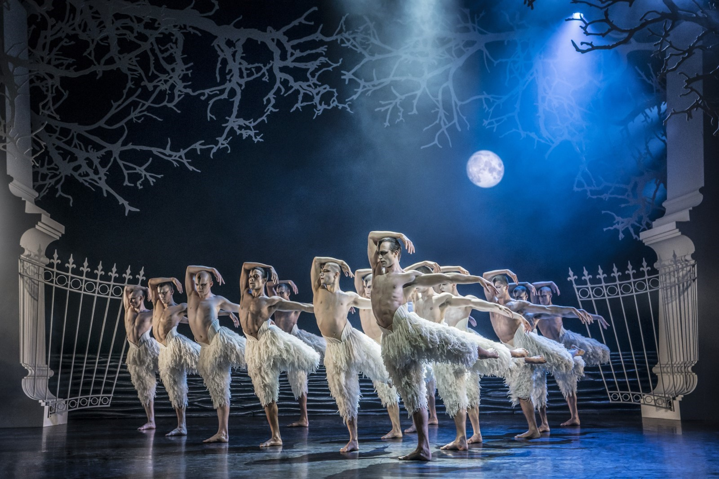**Matthew Bourne’s *Swan Lake* (Photo: Johan Persson)**

Matthew Bourne’s New Adventures is an award-winning, ground-breaking British dance-theatre company, famous for telling stories with a unique theatrical twist. Since 1987 New Adventures has changed the popularity of dance in Britain, creating works that have altered the public perception of what is possible when it comes to telling stories without words.      
    
New Adventures is a charity, and its principal funder is Arts Council England. As well as producing award-winning productions which dazzle audiences across the globe, New Adventures is committed to playing a meaningful role in diversifying the dance landscape for future generations. The company’s Take Part work reaches thousands each year through transformative workshops and masterclasses to schools and communities across Britain; the company’s many strands of talent development work nurture the best emerging talent from communities across the UK, springboarding them into our company and the wider sector.

**We work in the following key areas:**

➔  On Stage – large-scale, innovative and highly popular works that tour nationally and internationally .

➔  Talent Development – nurturing the next generation of dancers and choreographers, particularly seeking out those who have been historically excluded from pathways into the arts  .

➔  Young people and communities – participatory activity for people of all ages, including workshops, residencies and large-scale projects in partnership with other organisations

➔  REEL Adventures – ways of delivering on film, broadcast and digital platforms .

**Our core values are:**

➔  Audience – Our audiences are why we do what we do. Entertaining, engaging and inspiring audiences is our passion. We proudly tour to more venues and give more performances each year than any other dance company in the UK. We strive to be widely accessible and welcoming to both our loyal and new audiences.

➔  Adventure – Since the beginning we have been bold, maverick and adventurous. 30 years on we continue to push boundaries and defy expectations in dance, storytelling and ambition. We are committed to reaching as many people and places as possible through our productions and projects.

➔  Community – We have a shared commitment to supporting, developing and investing in all members of the New Adventures company and everyone involved with our work in whatever capacity – performers, creatives, crew, staff, practitioners, audiences, participants, trustees, students, interns, volunteers and partners. We all matter.

**Commitment to Equity, Diversity, and Inclusion**

New Adventures is committed to achieving a working environment which provides equity of opportunity and freedom from discrimination, harassment, and bullying. We believe that everyone is entitled to be treated with respect and dignity.   

One of our core company values is Community and we have a long-held and shared commitment to supporting, developing, and investing in all members of the New Adventures company and everyone involved with our work in whatever capacity - performers, creatives, crew, staff, dance artists, audiences, participants, trustees, students, and partners.   

We work together with partners e.g. [Creative Access](https://creativeaccess.org.uk/) and [Global Butterflies](https://globalbutterflies.com/), to help us achieve these aims.

We encourage applications from candidates of all backgrounds and welcome different points of view, skills, and stories.

Our freelancers, staff team and Trustees are actively engaged in equity, inclusion, and anti-racism work through programmed, facilitated learning sessions and our Equity, Diversity, Inclusion and Access (EDIA) Working Group. Anyone joining the company is expected to support and promote our Equity, Diversity, and Inclusion Policy.

## Job Description: Operations Manager

### Purpose

Working closely with the Leadership Team, the Operations Manager will support Matthew Bourne’s artistic vision by providing quality administrative and logistical support across the Company’s activities.

This role is key to supporting the running of the organisation, working across all Company activities, providing vital administrative support. Working closely with the team to ensure the efficient day-to-day running of the organisation, the Operations Manager is responsible for coordinating the smooth running of the premises, office systems and data collection and evaluation.

Responsible to: Chief Operating Officer

Responsible for: Company Assistant

### Key Responsibilities of the role

**Operations & Administration**

* Oversee the Overheads Budget including reforecasting on a quarterly basis with sign-off from the Chief Operating Officer.
* With the support of the Company Assistant, oversee the maintenance of office services and equipment including being responsible for the administration of equipment hire externally and in-house.
* With the support of the Company Assistant, oversee the office IT facilities, providing basic troubleshooting, and liaising with the IT consultant as required.
* Liaise with facilities management for any faults, repairs, or maintenance.
* Oversee the maintenance of office services and equipment and, in liaison with Building Services, working with the Chief Operating Officer on the Health and Safety of employees.
* With the Chief Operating Officer, undertake arrangements and negotiations for all issues relating to all insurances for New Adventures as required including managing insurance claim procedures and documentation.
* Work closely with the Chief Operating Officer to plan and deliver Green Adventures ensuring New Adventures' commitment to environmental sustainability is maintained, including:
  + Work as a key advisory role furthering our ambition to embed our commitment to environmental responsibility across the organisation.
  + Implement New Adventures strategy for Green Adventures, Take Part and touring productions, which will be implemented alongside our productions to include venue partnerships, data collection, carbon offsetting, and the roll out and annual review of key strategy documents including the Green Rider, Environmental Policy and Action Plan and Environmental Procurement Policy.
  + To support in leading and championing the work of Green Adventures, supporting them to build their knowledge and skills and identify key priority actions that can be implemented across a range of New Adventures’ activity.
  + Alongside New Adventures and Trustees as relevant, ensure the organisation is proactively delivery Arts Council England’s Investment Principle of ‘Environmental Responsibility’ and that this is reflected in the strategy for Green Adventures.
  + To work with the Chief Operating Officer on engaging the wider company in New Adventures environmental responsibility via the Green Adventures working group and annual data collection.
* With the Project Managers, oversee all DBS checks for the company and maintain the company’s DBS database.
* Carry out research as required by the Chief Operating Officer.

**Storage Management**

* Manage the company’s external storage unit including but not limited to managing the landlord relationship, contracting, and managing the sub-tenants.
* Manage and maintain utilities to the storage unit as required.
* Work alongside the Company’s storage manager to monitor the expenditure budget, manage relationships with external hires and subsidiaries, deal with emergency issues, review maintenance requirements and manage utilities.
* Managing the day-to-day relationship with clients who are renting space at the Manchester store, issuing contracts to new clients, and working with the Finance Manager to ensure that the correct fees are invoiced and paid each month.
* Maintaining log of client bookings in liaison with the Store Managers.

**Contracts**

* With the Chief Operating Officer and all other teams, ensure that contracts or agreements are in place with all partners and freelancers in a timely manner, including annual overarching agreements for freelance Dance Artists.
* Maintaining a centralised contracts/fees log and checking that any contracts issued by the Take Part, Communications, Finance and Operations and Development teams are properly logged.

**Human Resources**

* Support the Chief Operating Officer to ensure best practice in all operational areas and that effective policies are in place across the organisation, this includes but is not limited to redrafting policies for sign off by the SMT and trustees, regularly monitoring and reviewing the effectiveness of such policies and with the Chief Operating Officer maintain a Company Policy database to ensure regular rolling review of policies for the trustees.
* Additional tasks around specific policies may include:
  + Equal Opportunities – working within the EDIA policy.
  + Access and Inclusion – working with the Access & Inclusion officer.
  + Recruitment – see below.
  + Health & Safety – working environment e.g. DSE.
  + HR – including record keeping and BreatheHR. Ensure staff records are maintained and updated and held securely on the HR system and digital filing systems.
  + Health and Wellbeing – including EAP subscriptions and staff benefits.
  + Staff Handbooks – including in-year updates.
  + Training and Development – including booking training as directed.
* Manage the end-to-end recruitment process including:
  + Creating application packs and advertising roles
  + Preparing the shortlisting process for line managers
  + Inviting candidates to interview and liaising with line managers/panel over arrangements
  + Gathering feedback on the recruitment process and continuously striving to ensure the candidate recruitment process is the best it can be
  + Ensuring where possible to remove conscious or unconscious bias from the recruitment process
* Manage and maintain pre-employment checks including references and right-to-work.
* Ensure new employees receive all relevant new starter documentation and that contracts are issued before employment commences.
* In liaison with the relevant line manager, create new staff induction plans and provide operational induction which covers company systems and procedures.
* To participate in two New Adventures Working Groups – including chairing the Green Adventures Working Group.

**Placements Programme**

* Liaising with the Placements Programme Manager on the Company's Placements Programme including creation and maintenance of template contracts, advertising of Placement opportunities and organising interviews in line with New Adventures recruitment practices.
* Regularly review the content within the Placements Programme welcome packs with the Placements Programme Manager both in liaison with Director of Audience Engagement for branding purposes.
* Work with the relevant people to monitor, evaluate and report on the effectiveness of the Placements Programme.

**Data**

* Oversee the use of the company’s CRM (Contact Relationship Management) system reporting as required by the Chief Operating Officer in line with New Adventures Investment Principles and Business Plan.
* Manage the continued development of the company’s CRM system ensuring it is fit for purpose and work with relevant teams to develop processes for it to be used appropriately by the staff team.
* Draft and support the preparation of reports by providing statistical data, quotes, images, and text as requested by the New Adventures team.
* Support on GDPR for the Company, including working with the team to maintain GDPR logs, liaison with external consultants, stakeholders and regulatory bodies as required for compliance.
* Lead on monitoring, data collection and evaluation processes both qualitative and quantitative to meet the Arts Council Investment Principles requirements – this includes the maintenance of our KPI Dashboard and Environmental Impact reporting as required by the Chief Operating Officer in line with New Adventures Investment Principles and Business Plan.
* Coordinate Impact & Insight Toolkit responses and surveys as required for the New Adventures ACE funding agreement including liaising with venues to ensure circulation of surveys as required by the Chief Operating Officer in line with New Adventures Investment Principles and Business Plan.
* Conduct audience surveys in partnership with touring venues, the Illuminate platform, and Counting What Counts.
* Take Part/ Joint responsibility with the Take Part team to monitor, evaluate and report on the effectiveness of plans and activity, including audience and participant research and data collection – to include the set-up of project checklists.
* Work with the Inclusion and Access Officer to collect and analyse data to help identify trends, insights and gaps in EDIA data to inform strategy and relevant actions needed.
* Work with the Director of Audience Engagement to collate live and digital data on audience numbers etc as required for Arts Council England and other reporting, using sales reports, Showstats, CRM, Audience Finder, and Impact & Insight Toolkit (IIT).

**General**

* Take an active role in your continuing professional development, identifying relevant training and professional development opportunities.
* To always work in accordance with New Adventures’ Environmental Policy and Action Plan and to proactively develop and encourage environmentally sustainable practice.
* To embody the New Adventures Equality Plan, Dignity at Work Policy and any other policies or plans New Adventures may introduce in the future.

**Advocacy**

* Attend premieres, press nights and important company performances and events as required.
* Always act as an advocate for the company.
* Attend industry events as a representative of the company.
* On occasion tour with the company and represent the company at the presenting venues with overnight stays as required.

**Other**

* To always act in the best interests of New Adventures.
* To be an enthusiastic advocate of New Adventures and have a thorough understanding of the company’s mission, vision and aims.
* Other duties as reasonably required by your line manager.

### Person Specification

We will be using this to shortlist applicants. There may be some questions here that you can't confidently answer ‘yes’ to – don't be put off by this. If you still feel that you could do the job well, we want to hear from you.

**Knowledge & Experience**

* Do you have previous experience as a Company Coordinator, Office Administrator, or in a similar operations role?
* Are you fully IT literate and confident in using Microsoft Office packages and CRM systems?
* Do you have experience managing office budgets, including reconciliation and forecasting?
* Have you supported recruitment processes, including advertising, shortlisting, and managing pre-employment checks such as DBS and right-to-work documentation?
* Are you familiar with health and safety practices within a workplace environment and have you experience working with facilities management?
* Have you liaised with external suppliers or landlords to manage contracts, facilities, or storage units?
* Do you have experience collecting, analysing, and reporting data for monitoring and evaluation purposes?
* Can you demonstrate a proven ability to manage multiple pieces of work with a range of deadlines and competing priorities?
* Do you have experience communicating professionally and effectively with a wide range of stakeholders?

**Skills & Attributes**

* Are you a highly organised person with skills in prioritising multiple tasks and managing your time to meet deadlines?
* Do you approach your work with a high level of accuracy and attention to detail?
* Do you have excellent interpersonal skills with the ability to communicate confidently and tactfully with stakeholders at all levels?
* Are you skilled in planning ahead, problem-solving, and adapting to changing priorities?
* Can you maintain confidentiality and work with tact and diplomacy when handling sensitive information?
* Are you flexible, approachable, and able to work well both independently and collaboratively within a small team?
* Do you have exceptional written and verbal communication skills, including preparing professional documentation?
* Do you have a passion for and understanding of the arts and cultural sector?
* Do you bring a positive, approachable, and can-do attitude to your work?
* Do you willingly share ideas, resources, and information to support team collaboration and continuous improvement?

## Summary of Main Terms and Conditions

|  |  |
| --- | --- |
| Contract:  Salary: | Full-time, permanent.  £36,000-£39,000 per annum dependant on experience. |
| Hours of work: | The working week is 40 hours, including a one-hour lunch break each day. Usual office hours are 9am – 5pm / 10am – 6pm, Monday-Friday. The nature of the responsibilities is that additional working may be required. No overtime will be paid but time off in lieu (TOIL) may be taken with prior agreement in accordance with our TOIL policy. |
| Location: | Primary location London, with occasional travel to our base at Farnham Maltings and to tour locations around the UK. We currently work within a Hybrid Working model as we want to support our employees to do their best work, have a good work life balance and work flexibly whilst staying connected and retaining our sense of purpose and values. The Operations Manager would be required to work from the office on Tuesday, Wednesday and Thursday. Travel outside of commuting to your work base will be covered by New Adventures. |
| Line Manager: | Chief Operating Officer |
|  |  |

Probationary Period: Six months, during which time four week’s notice is required by both parties

Subsequent Notice Period: Three months from both parties.

Paid holiday entitlement: 20 days per annum, pro rata plus statutory Bank Holidays and employee birthday. Leave increases year-on-year by one day per year, up to a maximum of 25 days.

When possible, the office is closed between Christmas and the New Year, in addition to the annual holiday entitlement, as part of the company’s (TOIL) policy.

Benefits: Commitment to continued professional development through in-house training, development courses and personal training allowance.

Complimentary tickets and discounts for New Adventures shows, subject to the company’s ticket policy.

Cycle2Work scheme and Employee Assistance Programme.

Pension scheme: If the post holder meets the qualifying criteria, they will be automatically enrolled into the company pension scheme, which is with NEST. The employer’s contribution is 3% and employee 5%.

Identity checks: The successful applicant will need to provide official documents to confirm that they have the right to work in the UK.

References All offers of employment will be subject to receipt of satisfactory references.

## Equal Opportunities

New Adventures strives to be an Equal Opportunities Employer and to ensure that no person is unfairly discriminated against in its recruitment and selection policies and procedures. New Adventures welcomes applications from all sectors of the community, regardless of age, disability, gender identity or gender expression, race, ethnicity, religion or belief, sex, sexual orientation, or any other identity characteristic and makes appointments based solely on ability to fulfil the duties of the post. We actively welcome applications from individuals with backgrounds currently underrepresented in the arts.

Your application and any associated personal information will be stored and processed in accordance with our [Privacy Policy](https://new-adventures.net/legal/cookies). We will keep your equal opportunities form for a period of 6 months, after which point the data will be anonymised and aggregated for monitoring purposes. If you are employed by us, the information you supply will be kept securely and will form part of your employment record. All information will be treated in confidence and will not be seen by staff directly involved in the appointment and used only to provide information for monitoring and evaluation purposes.