

Company Assistant
Application Pack
Application Deadline:
Friday 9th January @ 10am

COMPANY ASSISTANT Application Pack
Thank you for your interest in the full-time role of Company Assistant at New Adventures.
This pack includes:
- how to apply
- information about the company
- a job description
- a person specification
- summary of the Main Terms and Conditions

How to apply
Before applying, please read the information and guidance notes provided in this pack carefully. We appreciate the time it takes in applying for roles and we want you to have the opportunity to tell us about yourself and explain why this position is right for you in whatever way feels most appropriate to you. All applications will be considered based on content, not on format.
Please send one of the following, together with a CV:
- A cover letter (maximum two A4 sides – either bullet points or full sentences, whichever you feel more comfortable with)
OR
- Presentation - Keynote or PowerPoint
OR
- Short video or sound file (5 minutes max)

All applications should address the following:
- Who you are
- What you could bring to New Adventures in this role.
- Your suitability for the position and specifically how your experience matches the role, job description and person specification.
- Provide details of two people who can comment on your work professionally including your current or previous employer. Please indicate how long and in what capacity your referees have known you. Referees will not be contacted without your permission.
We also ask applicants to complete our equal opportunities monitoring form which can be completed here.
Completion of the form is optional, and every question has a ‘prefer not to say’ option. The form will be kept separate from your application and will not be seen by the recruitment panel or form any part of the assessment of your application. Any information you provide on this form will only be used by New Adventures to better understand our reach and help improve future recruitment.
The deadline for applications is: Friday 9th January 2026 @ 10am

Submitting your application
If you are applying in writing, please submit your CV and cover letter to Beth Wilson, recruitment@new-adventures.net, with the subject field marked ‘Company Assistant Application’.
You can upload a video or audio file along with your equal opportunities form and CV to us using the We Transfer service https://wetransfer.com/ – when using this service please send your file to Beth Wilson, recruitment@new-adventures.net, with the subject field marked ‘Company Assistant Application’.
Your equal opportunities monitoring form should be completed online. If you require any support completing the form in this way, please let us know.
All applications will be acknowledged.

Recruitment and Project Timeline
Application Deadline: Friday 9th January 2026
Applicants invited to interview by Thursday 15th January 2026
First round interview (online): Thursday 22nd January 2026
Second round interview (in-person): Wednesday 28th January 2026
Interview Information

The interview will be a panel interview with a maximum 3 people that will last no longer than one hour. The names of the interview panellists and interview questions will be sent to you in advance.
Please let us know within your application if you are not available on any of the dates above. It is our intention for first round interviews to take place online, with a second round held at our office in London.

Commitment to Access
We will support any access requirements you may have during the recruitment process and ensure that reasonable adjustments are in place. If you have any access requirements, or barriers to access that you would like to discuss, please do not hesitate to let us know either before applying or as part of your application.
Candidates who are shortlisted for interview will be given the opportunity to specify any access requirements so that appropriate arrangements can be made. If you require this application pack in an alternative format, please contact us.
For Further Information

For an open and informal and confidential chat about the role, or to ask any questions, please contact Beth Wilson, Operations Manager, on 01252 597050 or recruitment@new-adventures.net
Please bear in mind that the office will be closed between Friday 19th December and Monday 5th January over our festive break, so we will not be available to answer questions during that period.

about the company
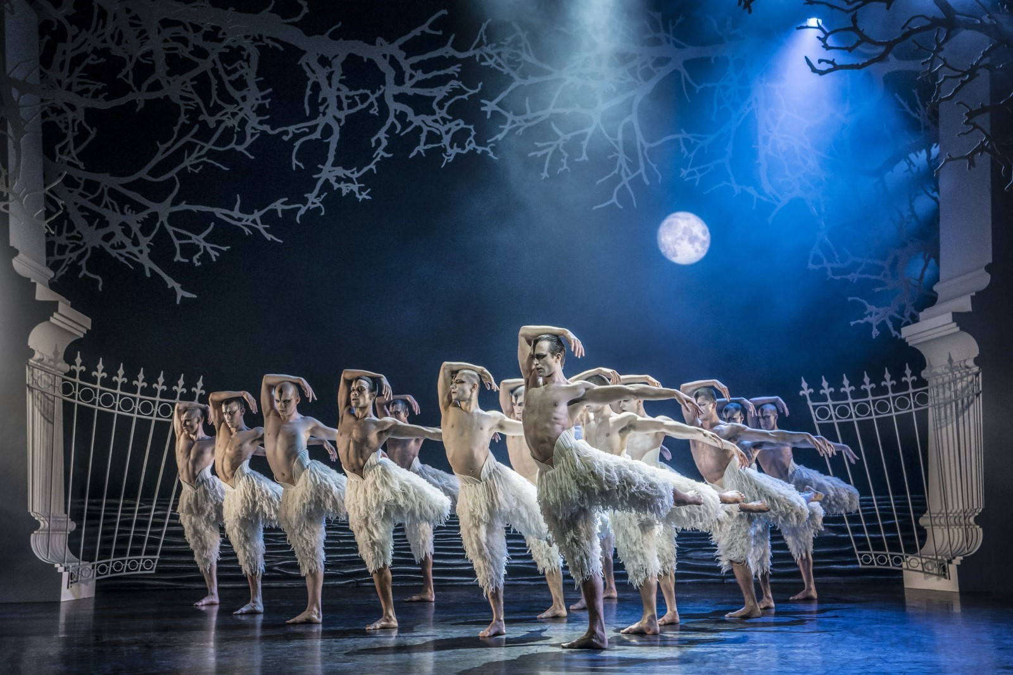Matthew Bourne’s Swan Lake (Photo: Johan Persson)
Matthew Bourne’s New Adventures is an award-winning, ground-breaking British dance-theatre company, famous for telling stories with a unique theatrical twist. Since 1987 New Adventures has changed the popularity of dance in Britain, creating works that have altered the public perception of what is possible when it comes to telling stories without words.
New Adventures is a charity, and its principal funder is Arts Council England. As well as producing award-winning productions which dazzle audiences across the globe, New Adventures is committed to playing a meaningful role in diversifying the dance landscape for future generations. The company’s Take Part work reaches thousands each year through transformative workshops and masterclasses to schools and communities across Britain; the company’s many strands of talent development work nurture the best emerging talent from communities across the UK, springboarding them into our company and the wider sector.
We work in the following key areas:
➔ On Stage – large-scale, innovative and highly popular works that tour nationally and internationally .
➔ Talent Development – nurturing the next generation of dancers and choreographers, particularly seeking out those who have been historically excluded from pathways into the arts .
➔ Young people and communities – participatory activity for people of all ages, including workshops, residencies and large-scale projects in partnership with other organisations
➔ REEL Adventures – ways of delivering on film, broadcast and digital platforms .

Our core values are:

➔ Audience – Our audiences are why we do what we do. Entertaining, engaging and inspiring audiences is our passion. We proudly tour to more venues and give more performances each year than any other dance company in the UK. We strive to be widely accessible and welcoming to both our loyal and new audiences.
➔ Adventure – Since the beginning we have been bold, maverick and adventurous. 30 years on we continue to push boundaries and defy expectations in dance, storytelling and ambition. We are committed to reaching as many people and places as possible through our productions and projects.
➔ Community – We have a shared commitment to supporting, developing and investing in all members of the New Adventures company and everyone involved with our work in whatever capacity – performers, creatives, crew, staff, practitioners, audiences, participants, trustees, students, interns, volunteers and partners. We all matter.

Commitment to Equity, Diversity, and Inclusion

New Adventures is committed to achieving a working environment which provides equity of opportunity and freedom from discrimination, harassment, and bullying. We believe that everyone is entitled to be treated with respect and dignity.
One of our core company values is Community and we have a long-held and shared commitment to supporting, developing, and investing in all members of the New Adventures company and everyone involved with our work in whatever capacity - performers, creatives, crew, staff, dance artists, audiences, participants, trustees, students, and partners.
We work together with partners e.g. Creative Access and Global Butterflies, to help us achieve these aims.

We encourage applications from candidates of all backgrounds and welcome different points of view, skills, and stories.

Our freelancers, staff team and Trustees are actively engaged in equity, inclusion, and anti-racism work through programmed, facilitated learning sessions and our Equity, Diversity, Inclusion and Access (EDIA) Working Group. Anyone joining the company is expected to support and promote our Equity, Diversity, and Inclusion Policy.




Job Description: COMPANY ASSISTANT

Purpose
Working closely across all teams the Company Assistant will support Matthew Bourne’s artistic vision by providing quality administrative and logistical support across the Company’s activities.

This is an important role at the centre of the New Adventures team. The role provides general administration and PA duties to the Senior Management Team and works closely with all areas of the organisation to ensure the smooth delivery of our activity and the efficient day-to-day running of the organisation.

Responsible to: Operations Manager

Key Responsibilities of the role
Administration and Coordination
- Act as the main point of contact for the New Adventures office including being the first point of contact for enquiries by telephone and by email.
- Support with enabling clear and sufficient communication amongst the team, including the sharing of calendars, diary management for the Executive Director and occasionally other members of the Senior Mangement Team, and regular updating of shared information – this also includes arranging appointments and meetings internally and externally.
- Supporting SMT to book travel and accommodation and processing expense claims as required and in line with company policy.
- Collate information from colleagues to produce and distribute our internal company diary document and CRM (Customer Relationship Management) system to help to better facilitate internal communications across the organisation.
- Support the Operations Manager with use of office space by managing room bookings and the office diary and supporting general management with access to the studio when needed.
- Take minutes of subcommittees (if needed), working groups and other meetings and circulate them to the team, and arrange links for hybrid versions of these meetings.
- Carry out research as required by the Operations Manager or SMT.
- Take a lead on organising internal company events and away days, booking event spaces and arranging hospitality. This includes birthday cards and gifts for staff throughout the year.
- To lead on merchandise coordination which includes overseeing/managing the merchandise operation and looking for opportunities to maximise sales.
- Support the Operations Manager to ensure that contracts or agreements are in place with all partners and freelancers including through maintenance of the centralised contracts log.
- Support with the administration and delivery of designated activity, from booking travel, accommodation and equipment and communications support, to supporting the pastoral care of participants during workshops or residencies as required.
Finance and Operations
- Manage the day to day running of the office and store cupboard ensuring that it is always safe, clean, and presentable.
- Oversee the maintenance of office services and equipment including being responsible for the administration of equipment hire externally and in-house.
- Oversee the office IT facilities, providing basic troubleshooting and liaising with the Operations Manager/IT consultant as required.
- Deal with post and arrange couriers.
- Keep the office stocked with supplies, such as stationery and refreshments.
- Book meeting rooms and facilities as needed.
- Meet and greet visitors, managing appointments at the office and provide refreshments.
- Supporting when required with finance related tasks including ensuring the correct and timely operation of certain aspects of the computerised purchase ledger (including processing invoices and credit card/soldo card administration).

General

- Take an active role in your continuing professional development, identifying relevant training and professional development opportunities.
- To always work in accordance with New Adventures’ Environmental Policy and Action Plan and to proactively develop and encourage environmentally sustainable practice.
- To embody the New Adventures Equality Plan, Dignity at Work Policy and any other policies or plans New Adventures may introduce in the future.

Advocacy

- Attend premieres, press nights and important company performances and events as required.
- Always act as an advocate for the company.
- Attend industry events as a representative of the company.
- On occasion tour with the company and represent the company at the presenting venues with overnight stays as required.

Other

- To always act in the best interests of New Adventures.
- To be an enthusiastic advocate of New Adventures and have a thorough understanding of the company’s mission, vision and aims.
- Other duties as reasonably required by your line manager.

Person Specification
We will be using this to shortlist applicants. There may be some questions here that you can't confidently answer ‘yes’ to – don't be put off by this. If you still feel that you could do the job well, we want to hear from you.

Knowledge & Experience

- Do you have experience in administration, or training relevant to an administrative role, ideally within the arts or charity sectors?
- Are you confident using Microsoft Office and able to learn new systems quickly (e.g., CRM platforms, accounting software)?
- Do you have demonstrated ability to manage multiple tasks, deadlines, and competing priorities?
- Do you have experience communicating professionally with a broad range of stakeholders?

Skills & Attributes

- Do you have strong organisational skills with the ability to prioritise tasks and manage time effectively?
- Do you have a positive, approachable attitude with a willingness to support colleagues across the organisation?
- Do you have high level of accuracy and attention to detail in all work?
- Are you a confident, tactful communicator with excellent interpersonal skills?
- Are you proactive, able to plan ahead and solve problems, and respond to changing priorities?
- Are you flexible and able to work effectively both independently and within a small team?
- Do you have strong written and verbal communication skills, including the preparation of professional documents?
- Do you have an interest in and understanding of the arts and cultural sector?

Summary of Main Terms and Conditions

Contract:  Salary: | Fixed term for 12 months  £30,000 per annum
Hours of work: | The working week is 40 hours, including a one-hour lunch break each day. Usual office hours are 9am – 5pm / 10am – 6pm, Monday-Friday. The nature of the responsibilities is that additional working may be required. No overtime will be paid but time off in lieu (TOIL) may be taken with prior agreement in accordance with our TOIL policy.
Location: | Primary location London, with occasional travel to our base at Farnham Maltings and to tour locations around the UK. We currently work within a Hybrid Working model as we want to support our employees to do their best work, have a good work life balance and work flexibly whilst staying connected and retaining our sense of purpose and values. The Company Assistant would be required to work from the office on Tuesday, Wednesday and Thursday. Travel outside of commuting to your work base will be covered by New Adventures.
Line Manager: | Operations Manager
Probationary Period: Three months, during which time four week’s notice is required by both parties
Subsequent Notice Period: Two months from both parties.
Paid holiday entitlement: 20 days per annum, pro rata plus statutory Bank Holidays and employee birthday. Leave increases year-on-year by one day per year, up to a maximum of 25 days.
When possible, the office is closed between Christmas and the New Year, in addition to the annual holiday entitlement, as part of the company’s (TOIL) policy.
Benefits: Commitment to continued professional development through in-house training, development courses and personal training allowance.
Complimentary tickets and discounts for New Adventures shows, subject to the company’s ticket policy.
Cycle2Work scheme and Employee Assistance Programme.
Pension scheme: If the post holder meets the qualifying criteria, they will be automatically enrolled into the company pension scheme, which is with NEST. The employer’s contribution is 3% and employee 5%.
Identity checks: The successful applicant will need to provide official documents to confirm that they have the right to work in the UK.
References All offers of employment will be subject to receipt of satisfactory references.

Equal Opportunities
New Adventures strives to be an Equal Opportunities Employer and to ensure that no person is unfairly discriminated against in its recruitment and selection policies and procedures. New Adventures welcomes applications from all sectors of the community, regardless of age, disability, gender identity or gender expression, race, ethnicity, religion or belief, sex, sexual orientation, or any other identity characteristic and makes appointments based solely on ability to fulfil the duties of the post. We actively welcome applications from individuals with backgrounds currently underrepresented in the arts.

Your application and any associated personal information will be stored and processed in accordance with our Privacy Policy. We will keep your equal opportunities form for a period of 6 months, after which point the data will be anonymised and aggregated for monitoring purposes. If you are employed by us, the information you supply will be kept securely and will form part of your employment record. All information will be treated in confidence and will not be seen by staff directly involved in the appointment and used only to provide information for monitoring and evaluation purposes.

