

**Head of Development**

Application Pack  
Application Deadline: Monday 30th September 2024 @ 10am



**Head of Development Application Pack**

Thank you for your interest in the full-time role of **Head of** **Development** at New Adventures.

The contents of this job pack include:

* how to apply
* information about the company
* a job description
* a person specification
* summary of Main Terms and Conditions

**How to apply**

Before applying, please read the information and guidance notes provided in this pack carefully. We appreciate the time it takes in applying for roles and we want you to have the opportunity to really tell us about yourself and explain why this position is right for you in whatever way feels most appropriate to you. All applications will be considered based on content, not on format.

Please send one of the following, together with a CV:

• A cover letter (maximum two A4 sides – either bullet points or full sentences, whichever you feel more comfortable with)

OR

• Presentation - Keynote or PowerPoint

OR

• Short video or sound file (5 minutes max)

All applications should address the following:

• Who you are

• What you could bring to New Adventures in this role

• Your suitability for the position and specifically how your experience matches the role, **job description** and **person specification**.

• Provide details of two people who can comment on your work professionally including your current or previous employer. Please indicate how long and in what capacity your referees have known you. Referees will not be contacted without your permission.

[We also ask applicants to complete our equal opportunities monitoring form which can be completed here.](https://forms.office.com/e/i4RSLLrgwH)

Completion of the form is optional and every question has a ‘prefer not to say’ option. Your answers really help us to understand how we are doing when trying to attract a broad range of candidates. The form will be kept separate from your application and will not be seen by the recruitment panel or form any part of the assessment of your application.

**The deadline for your application is: Monday 30th September 2024 @ 10am**

**Submitting your application**  
If you are applying in writing, please submit your CV and cover letter to Louise Miller, [louisemiller@new-adventures.net](mailto:louisemiller@new-adventures.net) with the subject field marked ‘Head of Development’.

You can upload a video or audio file along with your CV to us using the We Transfer service <https://wetransfer.com/> – when using this service please send your file to Louise Miller, [louisemiller@new-adventures.net](mailto:louisemiller@new-adventures.net) with ‘Head of Development’ in the subject line.

Your equal opportunities monitoring form should be completed online. If you require any support completing the form in this way, please let us know.

All applications will be acknowledged.

**Recruitment Timeline**  
Application deadline: Monday 30th September @ 10am

Application outcome received by: Monday 21st October 2024

First round interviews: Week commencing 28th October

Second round interviews: Week commencing 4th November

Interview information:

The first-round interview will be a panel interview with a maximum 3 people that will last no longer than one hour. The names of the interview panellists will be shared with you in advance.

The second-round interview will follow a similar format to the first round, but may also include an interview task, details of which and any preparation required will be shared with you in advance.

Please let us know within your application if you are not available on any of the above dates. It is our intention that interviews will take place at our office in London, however we can also hold interviews remotely. This will be discussed further on invitation to interview.

Contract commences: As soon as possible

**Commitment to Access**  
We will support any access requirements you may have during the recruitment process and ensure that reasonable adjustments are in place. If you have any access requirements, or barriers to access that you would like to discuss, please do not hesitate to let us know either before applying or as part of your application.

Candidates who are shortlisted for interview will be given the opportunity to specify any access requirements so that appropriate arrangements can be made. If you require this application pack in an alternative format, please contact us.

**For Further Information**

For an open, informal and confidential chat about the role, or to ask any questions, please contact Louise Miller, Operations Manager on [louisemiller@new-adventures.net](mailto:louisemiller@new-adventures.net)

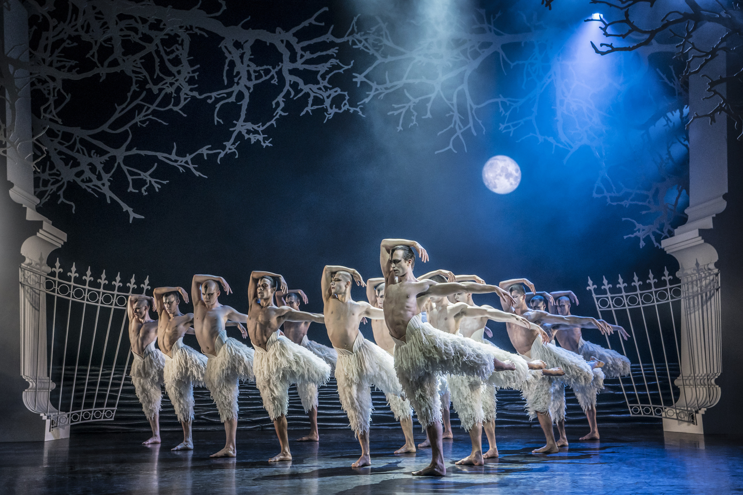**Information about the company**  
Matthew Bourne’s New Adventures is an award-winning, ground-breaking British dance-theatre company, famous for telling stories with a unique theatrical twist. Since 1987 New Adventures has changed the popularity of dance in Britain, creating works that have altered the public perception of what is possible when it comes to telling stories without words.   
  
New Adventures is a charity, and its principal funder is Arts Council England. As well as producing award-winning productions which dazzle audiences across the globe, New Adventures is committed to playing a meaningful role in diversifying the dance landscape for future generations. The company’s Take Part work reaches thousands each year through transformative workshops and masterclasses to schools and communities across Britain; the company’s many strands of talent development work nurture the best emerging talent from communities across the UK, springboarding them into our company and the wider sector.

**Matthew Bourne’s *Swan Lake* (Photo: Johan Persson)**

We work in the following key areas:   
➔ On Stage – large-scale, innovative and highly popular works that tour nationally and internationally

➔ Talent Development – nurturing the next generation of dancers and choreographers, particularly seeking out those who have been historically excluded from pathways into the arts

➔ Young people and communities – participatory activity for people of all ages, including workshops, residencies and large-scale projects in partnership with other organisations

➔ REEL Adventures – ways of delivering on film, broadcast and digital platforms

Our core values are:

➔ Audience – Our audiences are why we do what we do. Entertaining, engaging and inspiring audiences is our passion. We proudly tour to more venues and give more performances each year than any other dance company in the UK. We strive to be widely accessible and welcoming to both our loyal and new audiences.

➔ Adventure – Since the beginning we have been bold, maverick and adventurous. 30 years on we continue to push boundaries and defy expectations in dance, storytelling and ambition. We are committed to reaching as many people and places as possible through our productions and projects.

➔ Family – We have a shared commitment to supporting, developing and investing in all members of the New Adventures company and everyone involved with our work in whatever capacity – performers, creatives, crew, staff, practitioners, audiences, participants, trustees, students, interns, volunteers and partners. We all matter.

**Commitment to Equity, Diversity, and Inclusion**

New Adventures is committed to achieving a working environment which provides equity of opportunity and freedom from discrimination, harassment, and bullying. We believe that everyone is entitled to be treated with respect and dignity.

One of our core company values is Family and we have a long-held and shared commitment to supporting, developing, and investing in all members of the New Adventures company and everyone involved with our work in whatever capacity - performers, creatives, crew, staff, dance artists, audiences, participants, trustees, students, and partners.

We work together with partners to help us achieve these aims. Our current partners include [Creative Access](https://creativeaccess.org.uk/), and [PiPA](https://pipacampaign.org/)

We encourage applications from candidates of all backgrounds and welcome different points of view, skills, and stories. As a PiPA Charter Partner, we are happy to discuss solutions that allow people to balance their caring responsibilities with their working lives.

Our freelancers, staff team and Trustees are actively engaged in equity, inclusion, and anti-racism work through programmed, facilitated learning sessions and our Equity, Diversity, Inclusion and Access (EDIA) Working Group. Anyone joining the company is expected to support and promote our Equity, Diversity, and Inclusion Policy.

**Job Description: Head of Development**

**Purpose**

Working closely with the Senior Leadership Team, Development Associate and Development Officer, The Head of Development will support Matthew Bourne’s artistic vision by leading on the development and delivery of the New Adventures Fundraising Strategy to maximise voluntary income, particularly through Trusts and Foundations and Major Gifts. The post holder will work proactively to identify, cultivate engage and maintain excellent relationships with new and current donors and supporters as well as supporting the cultivation and stewardship of Corporate Supporters.

Responsible to: Deputy Managing Director

Key working relationships: Development Officer, Development Associate and Senior Management and Leadership Team

**Key Responsibilities**

**Strategy and Management**

* Together with the Deputy Managing Director and Group Managing Director, lead on the creation and implementation of the New Adventures fundraising strategy. This includes maintaining and enhancing understanding of New Adventures activities and future plans for planning of and applications to Trusts and Foundations, Major Gifts approaches and funder relationships.
* Work with the Finance and Operations team to manage and report on the Trusts and Foundations income stream including financial planning and achieving fundraising targets.
* With the support of the Development Officer, liaise with the Marketing and Communications team to create fundraising collateral and donor communications.
* With the support of the Development Officer, liaise with the wider team regarding data capture and analytics, in order to communicate New Adventures’ impact to relevant stakeholders.
* Keep up to date with current and future trends affecting philanthropy and donor recruitment, making recommendations that will inform our approach and the Fundraising Strategy.
* With the Deputy Managing Director and Group Managing Director, champion the importance of fundraising internally, engaging staff and Trustees, collating information about fundable projects and developing impact stories.
* With the support of the Development Officer, maximise gifts and advocacy from new and existing prospects, providing stewardship to encourage long term support as well as delivery and tracking of benefits.

**Administration and Finance**

* Contribute to the setting of annual income targets with the Group Managing Director and Deputy Managing Director.
* Manage agreed income and expenditure budgets. Including regular forecast updates to the Finance Manager on income and expenditure for reporting to the Board.
* Lead on the administration, reporting to and management of the quarterly Development Sub Committee meeting.
* With the support of the Development Officer, use the company’s CRM system to manage development data, track funder journeys and ensure the data that is stored is fit for purpose and GDPR compliant.
* Liaise with the Finance Manager and Development Officer to ensure that income is properly administered, including acknowledgement, financial receipts, maximising donation value and Gift Aid.
* Liaise with the Deputy Managing Director and the Chief Operating Officer to create and implement fundraising policies and processes. Including ensuring all fundraising activity meets legal requirements.
* Work with the Deputy Managing Director and the Take Part team to ensure evaluation requirements are integrated into funded projects from the outset.
* With the support of the Development Officer, manage processes for securing new and retaining existing supporters, including prospect research, writing and updating plans, initiating approaches, and providing briefing notes in advance of stakeholder meetings for colleagues as appropriate.

**Trusts and Foundations**

* Lead on the writing of applications to Trusts and Foundations and other grant giving bodies, build and continue to research prospects for New Adventures’ Trusts and Foundations pipeline.
* Work with the Deputy Managing Director to prioritise projects for Trusts and Foundations funding and targeted Philanthropy.
* Lead on developing relationships with current and prospective Trusts and Foundations, inviting them to get closer to the work through attendance at events, workshops, and performances where appropriate.
* Liaise with the Finance and Operations and Take Part teams to ensure application budgets comply with funders guidelines, and grants are spent in line with funding agreements.

**Major Gifts**

* Work with the Group Managing Director and Deputy Managing Director to cultivate, secure and steward major gifts (Gifts exceeding £5,000 in value).
* Identify projects and opportunities across the Artistic and Take Part programmes, which may be of interest to particular prospects.
* Lead the development and delivery of compelling asks for support from Individuals as well as tailored cultivation plans.
* Develop a strategy for growing the donor pipeline and securing new gifts including researching, identifying, and approaching new UK and International prospects across giving levels, including six figure donations.
* Build long–term relationships with supporters ensuring they are fully engaged and committed, that renewals are secured, and gift levels increased where possible.

**Corporate and Events**

* Support the Development Associate to secure and deliver cash and in-kind corporate partnerships.
* Support the Development Associate and Development Officer on events strategy and delivery and management.
* Working with the Development Associate develop creative ways for donors to engage with New Adventures through a bespoke and varied programme of Events, including gala nights, press nights, project visits, cultivation and members events, and other fundraising activities.
* Provide direction and briefing to the Development team and New Adventures staff ahead of donor engagement events.

**Line Management**

* Support the Development Officer to manage a reporting schedule for New Adventures funders.
* Support the Development Officer to deliver a timely thanking process for all levels of donations, gifts and grants.
* Support the Development Officer to provide timely donor communications around the charity’s Take Part work, events and donor stewardship programmes.
* Support the Development Officer to deliver and administer a new Regular Giving programme.

**Advocacy**

* To attend events, press/gala nights and important company performances and fundraising events, including occasional UK and International travel.
* Always act as an advocate for the company.
* To attend industry events as a representative of the company.
* On occasion, tour with the company and represent the company at the presenting venues with overnight stays as required.

**General**

* Take an active role in your continuing professional development, identifying relevant training and professional development opportunities.
* To work at all times in accordance with New Adventures’ Environmental Policy and Plan and to proactively develop and encourage environmentally sustainable practice.
* To embody the New Adventures policies and any other policies or plans New Adventures may introduce in the future.

**Other**

* Other Trusts and Foundations related administration as reasonably required.
* Other Major Giving related administration as reasonably required.
* Other fundraising and events duties as reasonably required by the Group Managing Director, Deputy Managing Director and Development Sub-Committee.

**Person Specification**

We will be using this to shortlist applicants. There may be some questions here that you can't confidently answer ‘yes’ to – don't be put off by this. If you still feel that you could do the job well, we want to hear from you.

**Knowledge and Experience**

* Do you have experience of implementing a fundraising strategy in line with the ambition of an organisation?
* Do you have knowledge about fundraising in the arts sector, including best practice, trends, opportunities and challenges?
* Do you have experience of working collaboratively with colleagues across different areas of an organisations operations i.e., finance and education?
* Do you have experience of working with a CRM system to support your workflow and track progress as well as record financial data?
* Do you have previous experience of writing successful Trusts and Foundations applications?
* Do you have knowledge of GDPR, data protection and fundraising compliance?
* Do you have line management experience?

**Skills and Attributes**

* Do you have excellent written and verbal communication skills?
* Do you have the ability to convey detailed information in a concise and compelling way?
* Are you a highly organized person with a proven ability to prioritise a wide range of tasks with effective time management in order to meet deadlines?
* Are you flexible, approachable and adaptable – with the ability to work well within and lead a small team?
* Do you willingly share ideas, resources and information with others?
* Do you have a positive, approachable, can-do attitude?

**Summary of Main Terms and Conditions**

Contract: Permanent

Salary: £45,000 - £50,000 (dependant on experience)

Hours of Work: The working week is 40 hours including a one-hour lunch break. Usual office hours are 9am/10am – 5pm/6pm, Monday to Friday. The nature of the responsibilities is that additional working may be required. No overtime will be paid but time off in lieu (TOIL) may be taken with prior agreement in accordance with our TOIL policy.

Location: Primary location London, with occasional travel to our base at Farnham Maltings and to tour locations around the UK. We currently work within a Hybrid Working model as we want to support our employees to do their best work, have a good work life balance and work flexibly whilst staying connected and retaining our sense of purpose and values.    

Line Manager: Deputy Managing Director

Probationary Period: 6 months during which time two week’ notice is required by both parties

Subsequent Notice Period: 3 months

Paid holiday entitlement: 20 days per annum plus statutory Bank Holidays. Leave increases year-on-year by one day per year, up to a maximum of 25 days. When possible, the office is closed between Christmas and the New Year, in addition to the annual holiday entitlement, as part of the company’s TOIL policy.

Pension scheme: If the post holder meets the qualifying criteria, they will be automatically enrolled into the company pension scheme, which is with NEST. The employer’s contribution is 3% and employee 5%.

Identity checks: The successful applicant will need to provide official documents to confirm that they have the right to work in the UK and undergo a check with the Disclosures and Barring Service (DBS).

References: All offers of employment will be subject to the receipt of satisfactory references.

Other Benefits: Commitment to CPD through in-house training and development courses.   
  
Complimentary tickets and discounts for New Adventures shows, subject to the company’s ticket policy.   
  
Birthday leave - discretionary additional day off on an employee’s birthday.

**Equal Opportunities**

New Adventures strives to be an Equal Opportunities Employer and to ensure that no person is unfairly discriminated against in its recruitment and selection policies and procedures. New Adventures welcomes applications from all sectors of the community, regardless of age, disability, gender identity or gender expression, race, ethnicity, religion or belief, sex, sexual orientation, or any other identity characteristic and makes appointments based solely on ability to fulfil the duties of the post. We actively welcome applications from individuals with backgrounds currently underrepresented in the arts.

Your application and any associated personal information will be stored and processed in accordance with our [Privacy Policy](https://new-adventures.net/legal/cookies). We will keep your equal opportunities form for a period of 6 months, after which point the data will be anonymised and aggregated for monitoring purposes. If you are employed by us, the information you supply will be kept securely and will form part of your employment record. All information will be treated in confidence and will not be seen by staff directly involved in the appointment and used only to provide information for monitoring and evaluation purposes.