

**Company Assistant**

Application Pack  
Application Deadline: Wednesday 11th December 2024 @ 10am



**Company Assistant Application Pack**

Thank you for your interest in the full-time role of **Company Assistant** at New Adventures.

The contents of this job pack include:

* how to apply
* information about the company
* a job description
* a person specification
* summary of Main Terms and Conditions

**How to apply**

Before applying, please read the information and guidance notes provided in this pack carefully. We appreciate the time it takes in applying for roles and we want you to have the opportunity to really tell us about yourself and explain why this position is right for you in whatever way feels most appropriate to you. All applications will be considered based on content, not on format.

Please send one of the following, together with a CV:

• A cover letter (maximum two A4 sides – either bullet points or full sentences, whichever you feel more comfortable with)

OR

• Presentation - Keynote or PowerPoint

OR

• Short video or sound file (5 minutes max)

All applications should address the following:

• Who you are

• What you could bring to New Adventures in this role

• Your suitability for the position and specifically how your experience matches the role, **job description** and **person specification**.

• Provide details of two people who can comment on your work professionally including your current or previous employer. Please indicate how long and in what capacity your referees have known you. Referees will not be contacted without your permission.

[We also ask applicants to complete our equal opportunities monitoring form which can be completed here.](https://forms.office.com/e/i4RSLLrgwH)

Completion of the form is optional and every question has a ‘prefer not to say’ option. Your answers really help us to understand how we are doing when trying to attract a broad range of candidates. The form will be kept separate from your application and will not be seen by the recruitment panel or form any part of the assessment of your application.

**The deadline for your application is: Wednesday 11th December 2024 @ 10am**

**Submitting your application**  
If you are applying in writing, please submit your CV and cover letter to Louise Miller, [louisemiller@new-adventures.net](mailto:louisemiller@new-adventures.net) with the subject field marked ‘Company Assistant Application’.

You can upload a video or audio file along with your CV to us using the We Transfer service <https://wetransfer.com/> – when using this service please send your file to Louise Miller, [louisemiller@new-adventures.net](mailto:louisemiller@new-adventures.net) with ‘Company Assistant Application’ in the subject line.

Your equal opportunities monitoring form should be completed online. If you require any support completing the form in this way, please let us know.

All applications will be acknowledged.

**Recruitment Timeline**  
Application deadline: Wednesday 11th December @ 10am

Application outcome received by: Wednesday 18th December

First round interviews: Tuesday 7th January

Second round interviews: Tuesday 14th January

Interview information:

The interview will be a panel interview with a maximum 3 people that will last no longer than one hour. The names of the interview panellists, interviews questions and interview task will be shared with you in advance.

Please let us know within your application if you are not available on the date above. It is our intention that interviews will take place at our office in London, however we can also hold interviews remotely. This will be discussed further on invitation to interview.

Contract commences: As soon as possible

**Commitment to Access**  
We will support any access requirements you may have during the recruitment process and ensure that reasonable adjustments are in place. If you have any access requirements, or barriers to access that you would like to discuss, please do not hesitate to let us know either before applying or as part of your application.

Candidates who are shortlisted for interview will be given the opportunity to specify any access requirements so that appropriate arrangements can be made. If you require this application pack in an alternative format, please contact us.

**For Further Information**

For an open, informal and confidential chat about the role, or to ask any questions, please contact Louise Miller, Operations Manager on [louisemiller@new-adventures.net](mailto:louisemiller@new-adventures.net) or call 01252 597050.

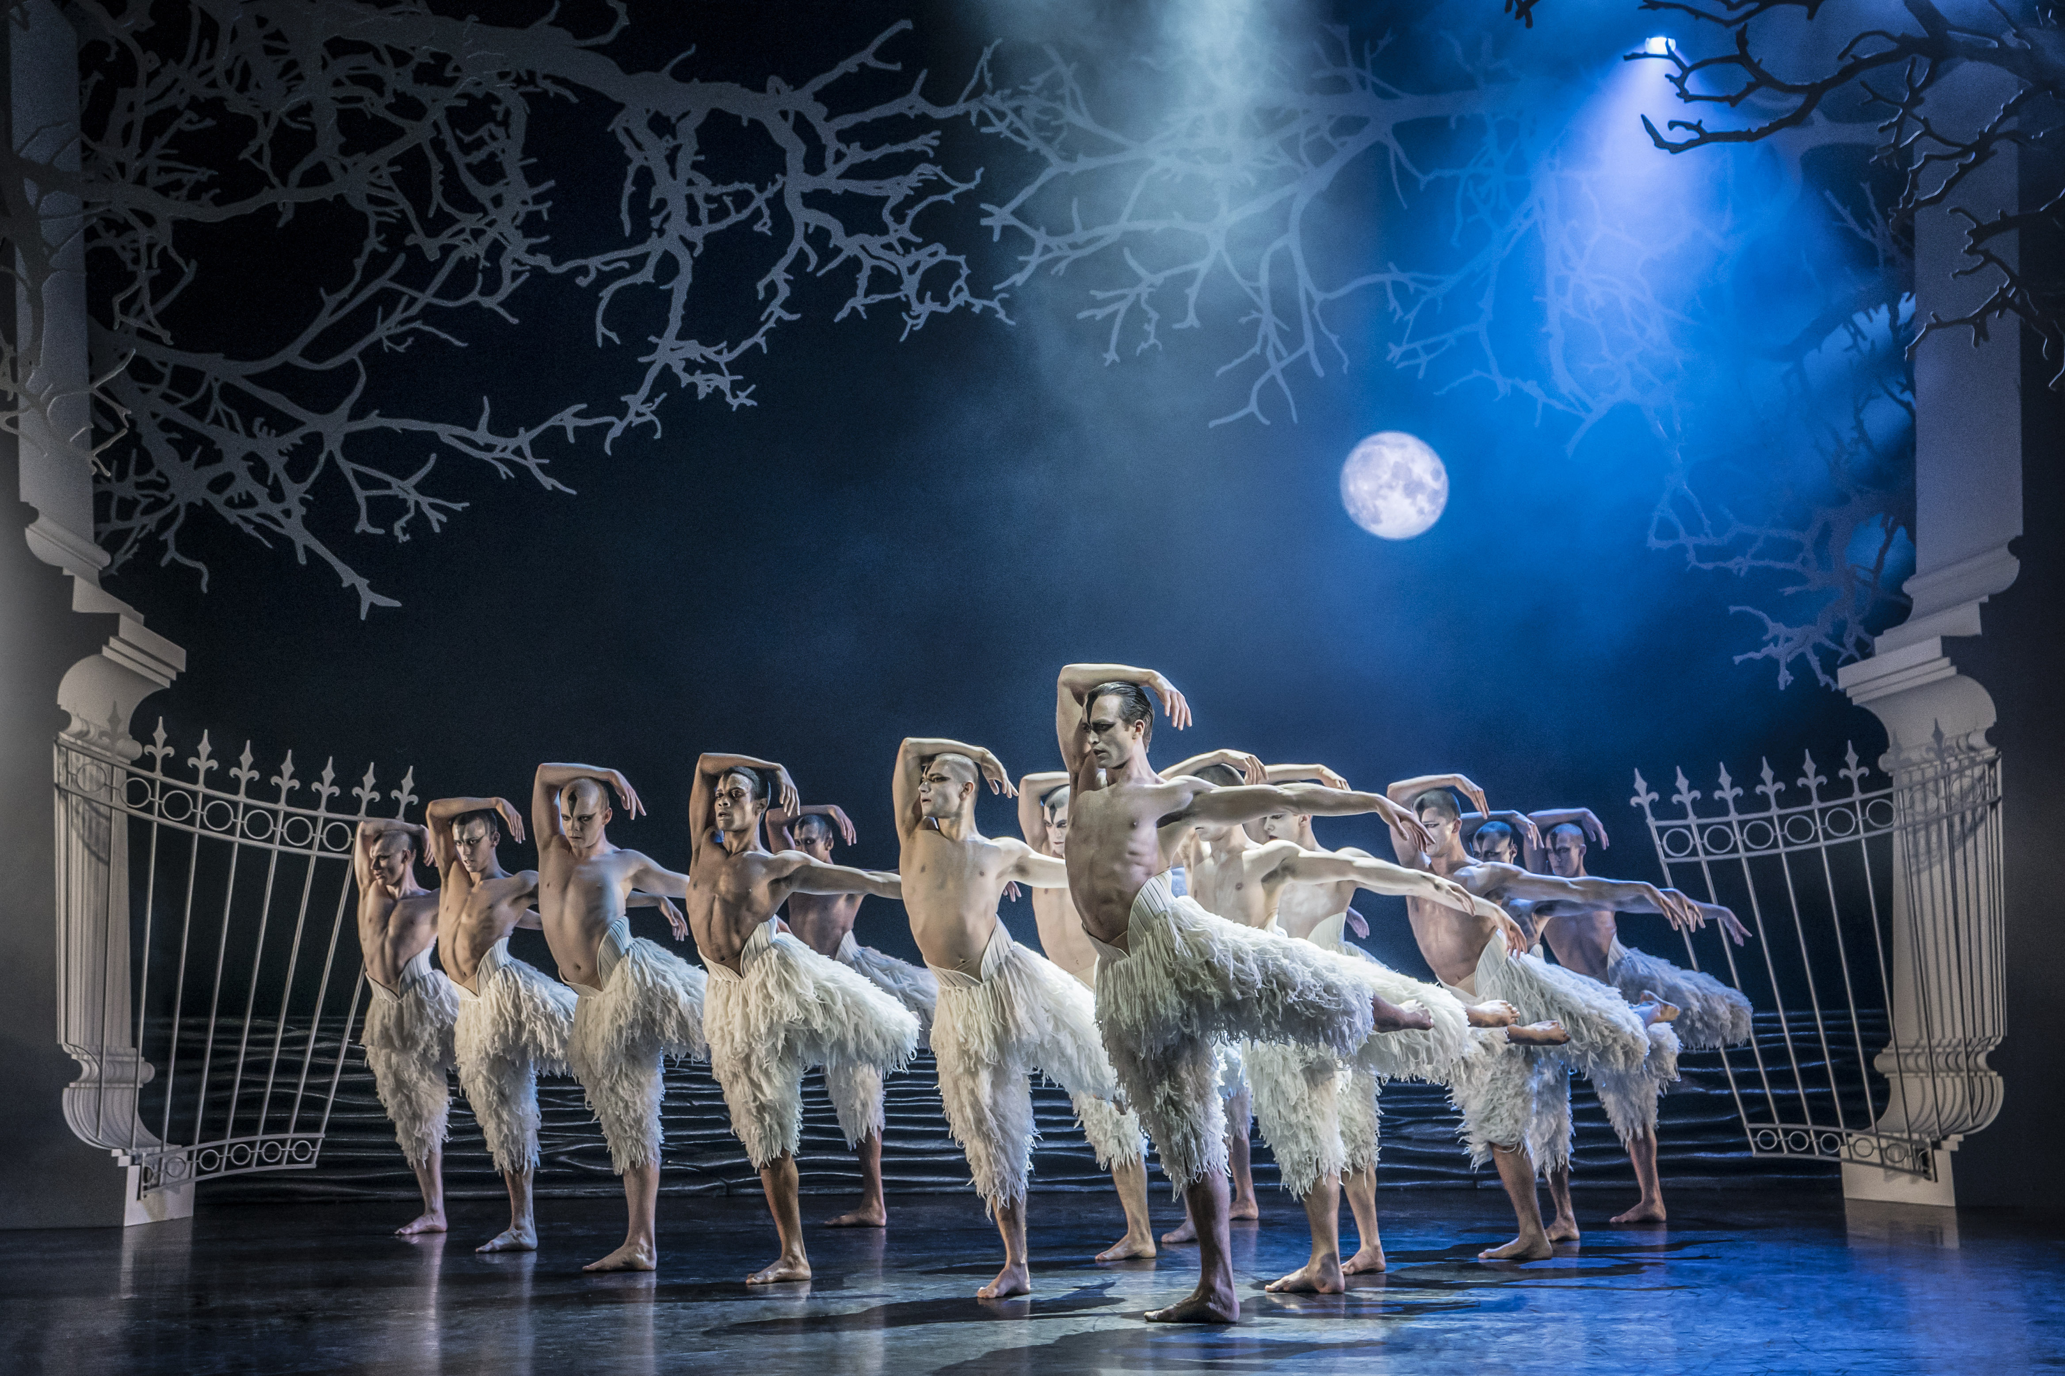**Information about the company**  
Matthew Bourne’s New Adventures is an award-winning, ground-breaking British dance-theatre company, famous for telling stories with a unique theatrical twist. Since 1987 New Adventures has changed the popularity of dance in Britain, creating works that have altered the public perception of what is possible when it comes to telling stories without words.   
  
New Adventures is a charity, and its principal funder is Arts Council England. As well as producing award-winning productions which dazzle audiences across the globe, New Adventures is committed to playing a meaningful role in diversifying the dance landscape for future generations. The company’s Take Part work reaches thousands each year through transformative workshops and masterclasses to schools and communities across Britain; the company’s many strands of talent development work nurture the best emerging talent from communities across the UK, springboarding them into our company and the wider sector.

**Matthew Bourne’s *Swan Lake* (Photo: Johan Persson)**

We work in the following key areas:   
➔ On Stage – large-scale, innovative and highly popular works that tour nationally and internationally

➔ Talent Development – nurturing the next generation of dancers and choreographers, particularly seeking out those who have been historically excluded from pathways into the arts

➔ Young people and communities – participatory activity for people of all ages, including workshops, residencies and large-scale projects in partnership with other organisations

➔ REEL Adventures – ways of delivering on film, broadcast and digital platforms

Our core values are:

➔ Audience – Our audiences are why we do what we do. Entertaining, engaging and inspiring audiences is our passion. We proudly tour to more venues and give more performances each year than any other dance company in the UK. We strive to be widely accessible and welcoming to both our loyal and new audiences.

➔ Adventure – Since the beginning we have been bold, maverick and adventurous. 30 years on we continue to push boundaries and defy expectations in dance, storytelling and ambition. We are committed to reaching as many people and places as possible through our productions and projects.

➔ Family – We have a shared commitment to supporting, developing and investing in all members of the New Adventures company and everyone involved with our work in whatever capacity – performers, creatives, crew, staff, practitioners, audiences, participants, trustees, students, interns, volunteers and partners. We all matter.

**Commitment to Equity, Diversity, and Inclusion**

New Adventures is committed to achieving a working environment which provides equity of opportunity and freedom from discrimination, harassment, and bullying. We believe that everyone is entitled to be treated with respect and dignity.

One of our core company values is Family and we have a long-held and shared commitment to supporting, developing, and investing in all members of the New Adventures company and everyone involved with our work in whatever capacity - performers, creatives, crew, staff, dance artists, audiences, participants, trustees, students, and partners.

We work together with partners e.g [Creative Access](https://creativeaccess.org.uk/), to help us achieve these aims.

We encourage applications from candidates of all backgrounds and welcome different points of view, skills, and stories.

Our freelancers, staff team and Trustees are actively engaged in equity, inclusion, and anti-racism work through programmed, facilitated learning sessions and our Equity, Diversity, Inclusion and Access (EDIA) Working Group. Anyone joining the company is expected to support and promote our Equity, Diversity, and Inclusion Policy.

**Job Description: Company Assistant**

**Purpose**

Working closely with the Senior Management Team (SMT), the Company Assistant will support Matthew Bourne’s artistic vision by providing quality administrative and executive assistant support across the Company’s activities.

**Context**

This is an important role at the centre of the New Adventures team. The role provides general administration and PA duties to Senior Management Team and works closely with all areas of the organisation to ensure the smooth delivery of our activity.

Responsible to: Operations Manager

Key working relationships: Senior Management Team, Finance Manager

**Key Responsibilities**

**Administration and Coordination**

* Act as the main point of contact for the New Adventures office including being the first point of contact for enquiries by telephone and by email.
* Support with enabling clear and sufficient communication amongst the team, including the sharing of calendars, diary management for the SMT and regular updating of shared information – this also includes arranging appointments and meetings internally and externally.
* Supporting SMT to book travel and accommodation and processing expense claims as required and in line with company policy.
* Collate information from colleagues to produce and distribute our internal company diary document and help to facilitate better internal communications across the organisation.
* Take minutes of subcommittees (if needed), working groups and other meetings and circulate them to the team.
* Carry out research as required by the SMT.
* Support SMT to organise internal company events, training and away days, book event spaces and arrange hospitality.
* To lead on merchandise coordination which includes overseeing/managing the merchandise operation and looking for opportunities to maximise sales.
* Support the Operations Manager to ensure that contracts or agreements are in place with all partners and freelancers including through maintenance of the centralised contracts log.
* Support with the administration and delivery of designated activity, from booking travel, accommodation and equipment and communications support, to supporting the pastoral care of participants during workshops or residencies as required.

**Finance and Operations**

* Manage the day to day running of the office and store cupboard ensuring that it is always safe, clean, and presentable.
* Oversee the maintenance of office services and equipment including being responsible for the administration of equipment hire externally and in-house.
* Oversee the office IT facilities, providing basic troubleshooting and liaising with the Operations Manager/IT consultant as required.
* Deal with post and arrange couriers.
* Keep the office stocked with supplies, such as stationery and refreshments.
* Book meeting rooms and facilities as needed.
* Meet and greet visitors and provide refreshments.
* Ensuring the correct and timely operation of certain aspects of the computerised purchase ledger (including processing invoices and credit card administration).

**Advocacy**

* Attend galas, supporters’ nights and important company performances and events as required.
* Always act as an advocate for the company.
* On occasion tour with the company and represent the company at the presenting venues with overnight stays as required.

**General**

* Take an active role in your continuing professional development, identifying relevant training and professional development opportunities.
* To always work in accordance with New Adventures’ Environmental Policy and Action Plan and to proactively develop and encourage environmentally sustainable practice.
* To embody the New Adventures current policies and other policies or plans New Adventures may introduce in the future.
* To always act in the best interests of the New Adventures.
* To be an enthusiastic advocate of New Adventures and have a thorough understanding of the company’s mission, vision and aims.
* Other duties as reasonably required by your line manager.

**Person Specification**

We will be using this to shortlist applicants. There may be some questions here that you can't confidently answer ‘yes’ to – don't be put off by this. If you still feel that you could do the job well, we want to hear from you.

**Knowledge and Experience**

* Do you have experience of working within administration, or training relevant to an administration role, ideally within the arts or charity sectors?
* Do you have experience of Microsoft Office and are you able to quickly develop skills in other systems? e.g. Contact Relationship Management systems and Accounting software?

**Skills and Attributes**

* Do you have exceptional written and verbal communication skills with the ability to communicate with stakeholders at all levels?
* Do you have outstanding organisational skills, with the ability to coordinate multiple tasks simultaneously as well as being able to prioritise and plan ahead?
* Are you able to work with tact, diplomacy and complete confidentiality?
* Do you have excellent attention to detail and accuracy?
* Are you able to work collaboratively as part of a small team as well as independently?

**Summary of Main Terms and Conditions**

Contract: Fixed-term until March 2026

Salary: £28,720

Hours of Work: The working week is 40 hours including a one-hour lunch break. Usual office hours are 9am/10am – 5pm/6pm, Monday to Friday. The nature of the responsibilities is that additional working may be required. No overtime will be paid but time off in lieu (TOIL) may be taken with prior agreement in accordance with our TOIL policy.

Location: Primary location London, with occasional travel to our base at Farnham Maltings and to tour locations around the UK. We currently work within a Hybrid Working model with employees working in the office for 60% of the working week as we want to support our employees to do their best work, have a good work life balance and work flexibly whilst staying connected and retaining our sense of purpose and values.

Line Manager: Operations Manager

Probationary Period: Three months during which time two weeks’ notice is required by both parties

Subsequent Notice Period: Two months

Paid holiday entitlement: 20 days per annum plus statutory Bank Holidays. Leave increases year-on-year by one day per year, up to a maximum of 25 days. When possible, the office is closed between Christmas and the New Year, in addition to the annual holiday entitlement, as part of the company’s TOIL policy.

Pension scheme: If the post holder meets the qualifying criteria, they will be automatically enrolled into the company pension scheme, which is with NEST. The employer’s contribution is 3% and employee 5%.

Identity checks: The successful applicant will need to provide official documents to confirm that they have the right to work in the UK and undergo a check with the Disclosures and Barring Service (DBS).

References: All offers of employment will be subject to the receipt of satisfactory references.

Other Benefits: Commitment to CPD through in-house training and development courses.   
  
Complimentary tickets and discounts for New Adventures shows, subject to the company’s ticket policy.   
  
Birthday leave - discretionary additional day off on an employee’s birthday.

**Equal Opportunities**

New Adventures strives to be an Equal Opportunities Employer and to ensure that no person is unfairly discriminated against in its recruitment and selection policies and procedures. New Adventures welcomes applications from all sectors of the community, regardless of age, disability, gender identity or gender expression, race, ethnicity, religion or belief, sex, sexual orientation, or any other identity characteristic and makes appointments based solely on ability to fulfil the duties of the post. We actively welcome applications from individuals with backgrounds currently underrepresented in the arts.

Your application and any associated personal information will be stored and processed in accordance with our [Privacy Policy](https://new-adventures.net/legal/cookies). We will keep your equal opportunities form for a period of 6 months, after which point the data will be anonymised and aggregated for monitoring purposes. If you are employed by us, the information you supply will be kept securely and will form part of your employment record. All information will be treated in confidence and will not be seen by staff directly involved in the appointment and used only to provide information for monitoring and evaluation purposes.